**Slip 1**

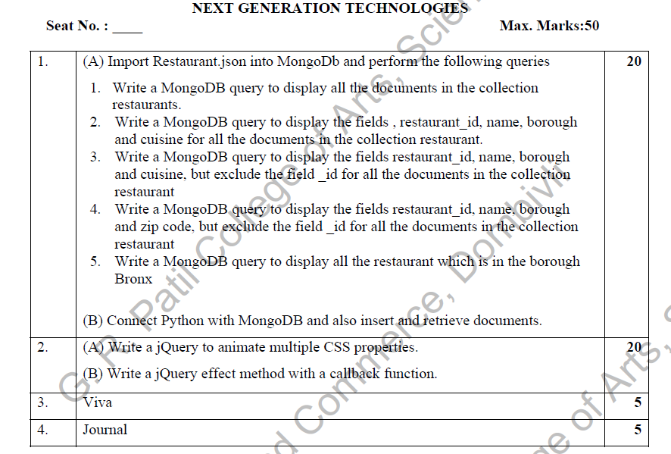

Solution

1.A)

1.

Code:

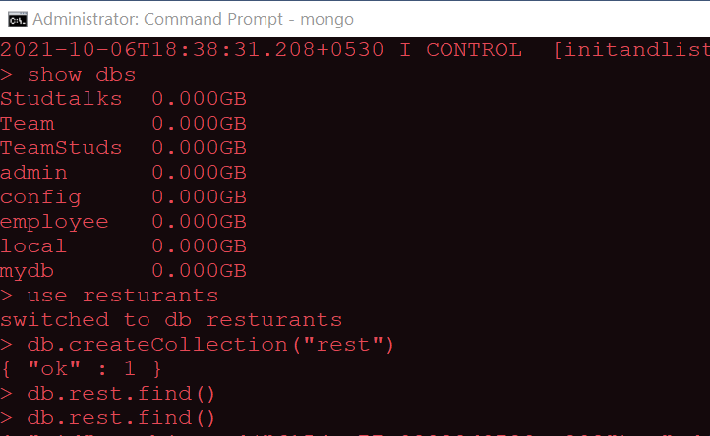

Again open the command prompt to import the restaurant.json file

db.rest.find().pretty()

Output:

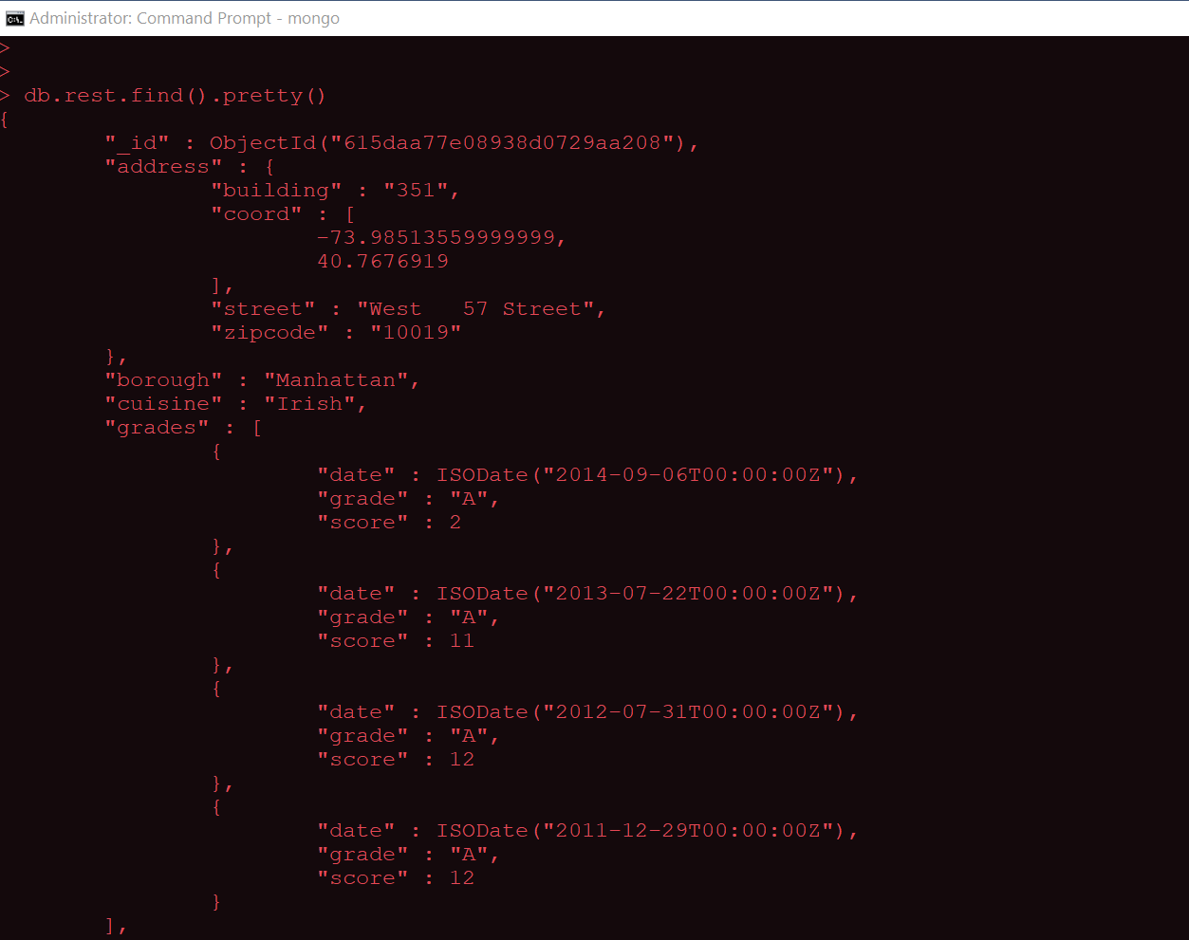

2:

Code:

db.rest.find({},{"restaurant_id":1,"name":1,"borough":1,"cusinie":1}).pretty()

Output:

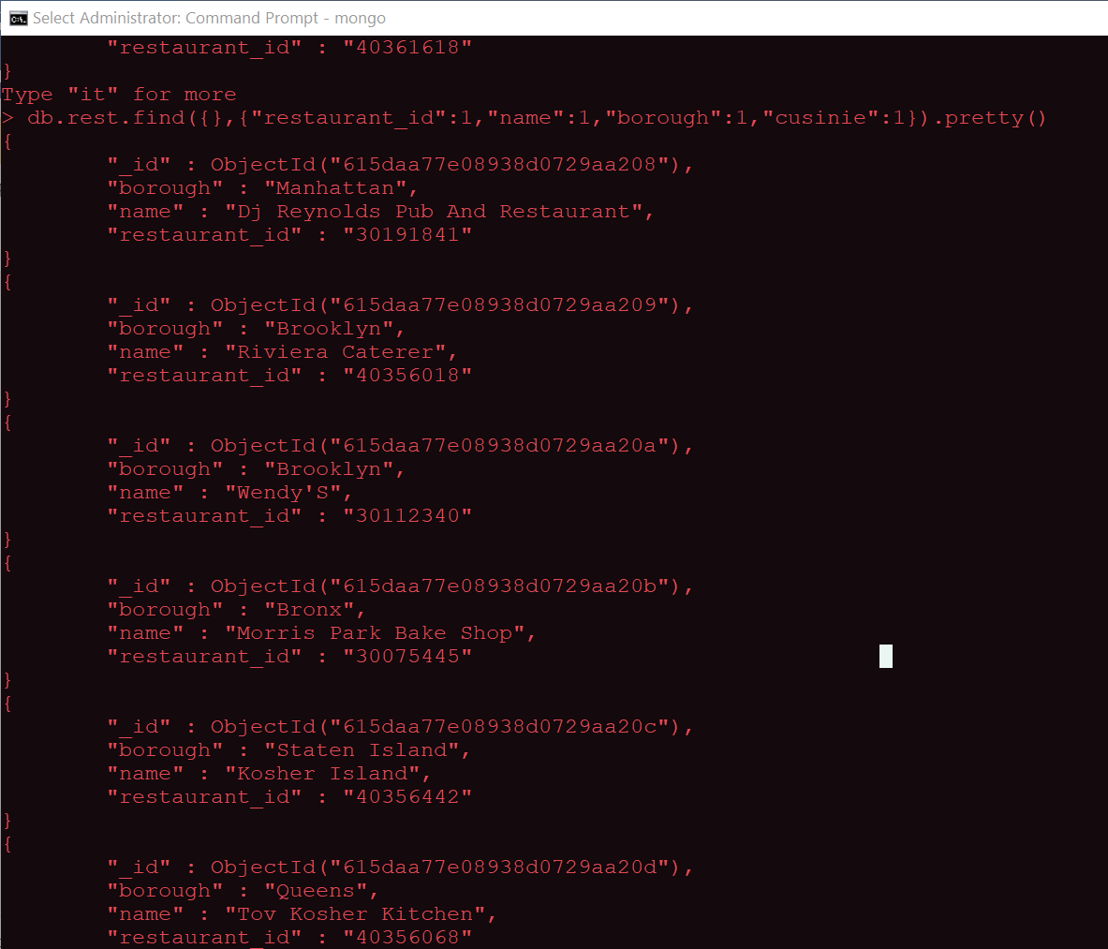

3.

Code:

db.rest.find({},{"restaurant_id":1,"name":1,"borough":1,"cusine":1,"_id":0}).pretty()

Output:

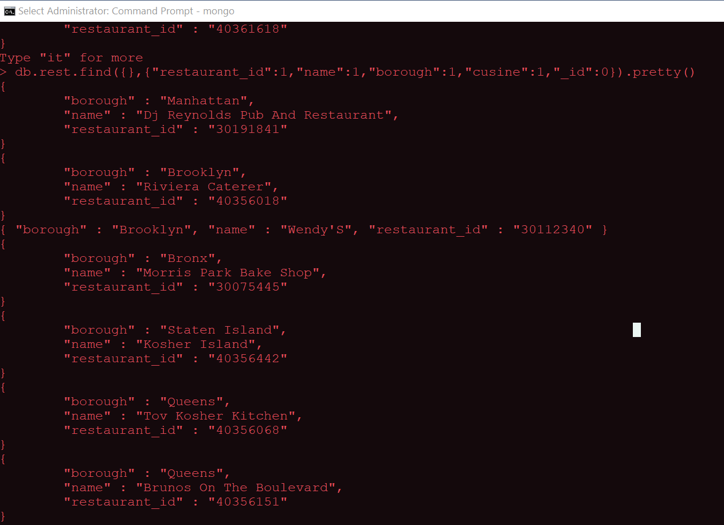

4.

Code:

db.rest.find({},{"restaurant_id":1,"name":1,"borough":1,"address.zipcode":1,"_id":0}).pretty()

Output:

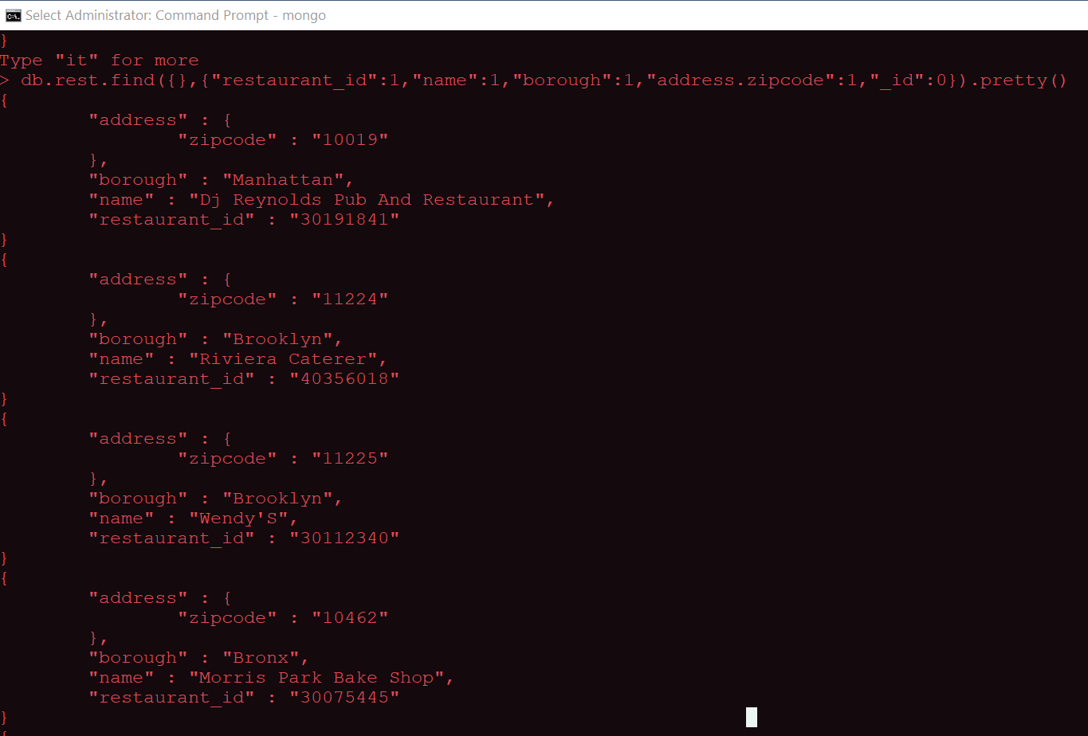

5.

Code:

db.rest.find({"borough":"Bronx"}).pretty()

Output:

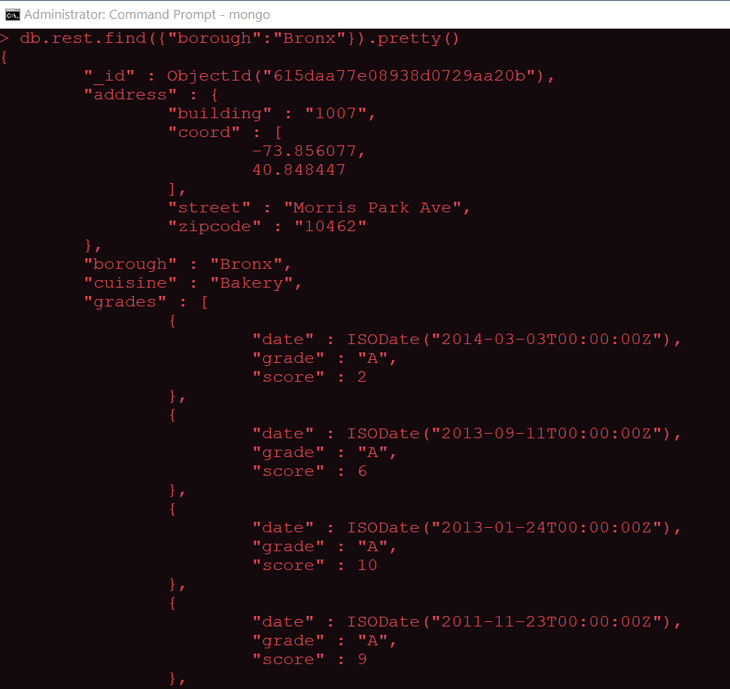

B)

Insert

Code:

from pymongo import MongoClient

client=MongoClient('localhost',27017)

db=client.Studtalks

def insert():

try:

Name=input("Enter Name : ")

Age=input("Enter Age : ")

Dept=input("Department : ")

Contro=input("Contributed for : ")

db.Teammates.insert(

{

"NAME":Name,

"AGE":Age,

"Deptname":Dept,

"ControTo":Contro

}

)

print("Inserted data successfully ")

except Exception:

print(str(e))

insert()

Output:

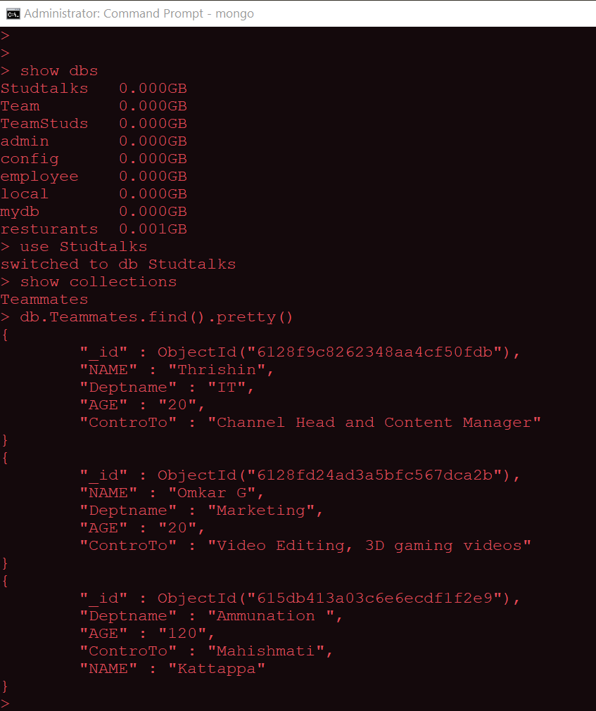

Reterive

Code:

from pymongo import MongoClient

client=MongoClient('localhost',27017)

db=client.Studtalks

def read():

try:

Col = db.Teammates.find()

print("\n All data from Studtalks Database \n")

for Teammates in Col:

print(Teammates)

except Exception:

print(str(e))

read()

Output:

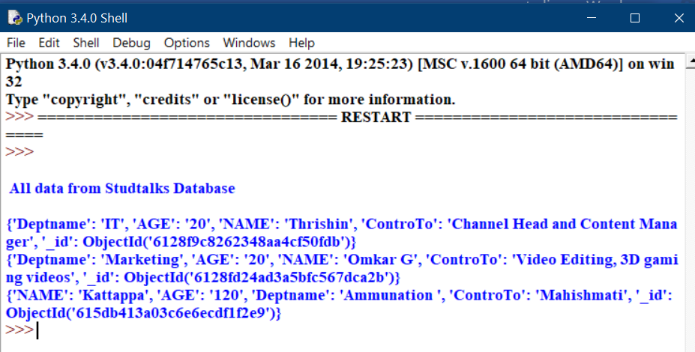

2 A

Code:

<!DOCTYPE html>

<html>

<head>

    <title></title>

    <script src="jquery-3.6.0.min.js"></script>

    <style type="text/css">

        .box {

            width: 100px;

            height: 100px;

            background: #9d7ede;

            margin-top: 30px;

            border-style: solid;

            border-color: #6f40ce;

        }

    </style>

    <script>

        $(document).ready(

            function () {

                $("button").click(

                    function () {

                        $(".box").animate(

                            {

                                width: "300px",

                                height: "300px",

                                marginLeft: "150px",

                                borderWidth: "10px",

                                opacity: 0.5

                            }

                        );

                    }

                );

            }

        );

    </script>

</head>

<body>

    <button type="button">Start Animation</button>

    <div class="box"></div>

</body>

</html>

Output:

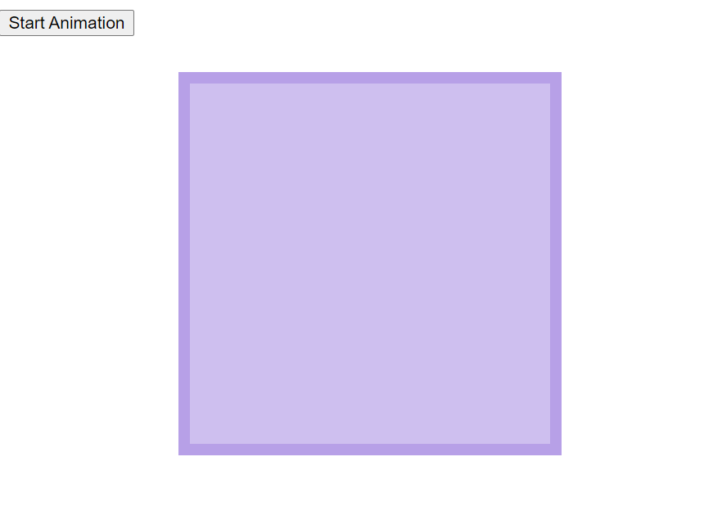

B.

Code:

<!DOCTYPE html>

<html>

<head>

    <title></title>

    <script src="jquery-3.6.0.min.js"></script>

    <script>

        $(document).ready(

            function () {

                $("button").click(

                    function () {

                        $("p").hide("slow", function () {

                            alert("The paragraph is now hidden");

                        }

                        );

                    }

                );

            }

        );

    </script>

</head>

<body>

    <button>click</button>

    <p>This is a paragraph </p>

</body>

</html>

Output:

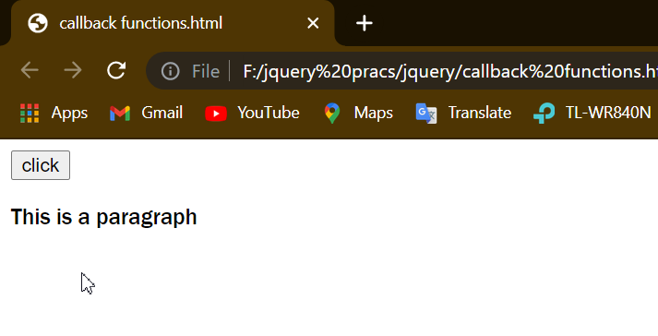

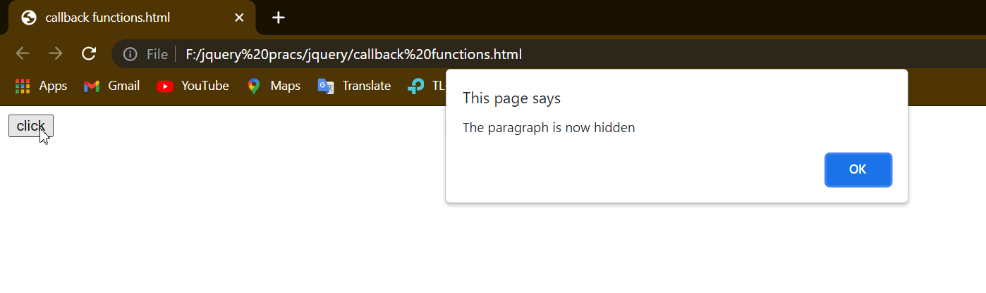

**Slip 2**



1.

Inserting data into database

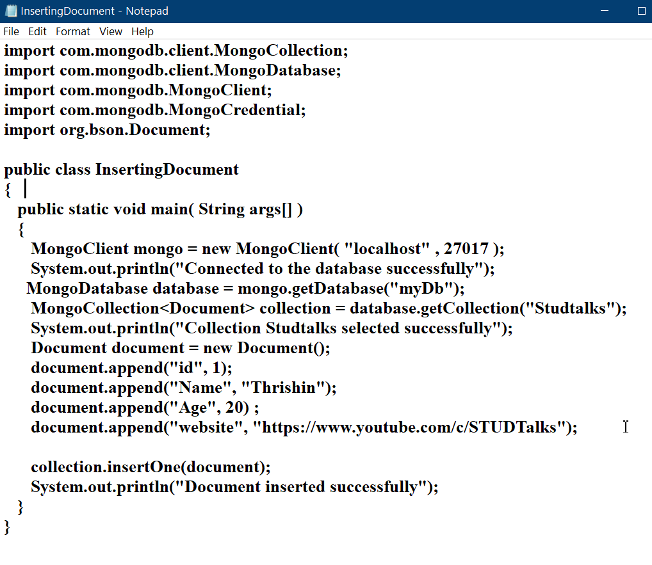

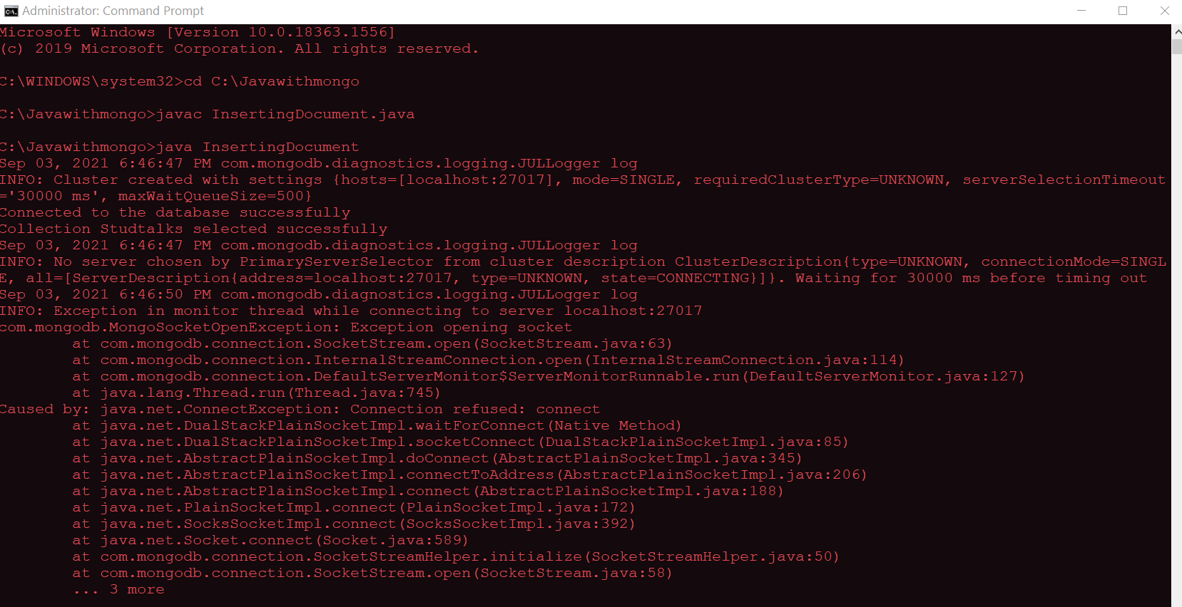

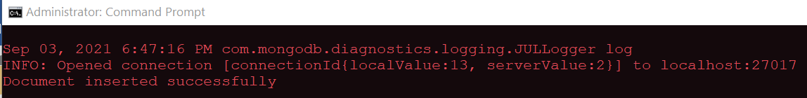

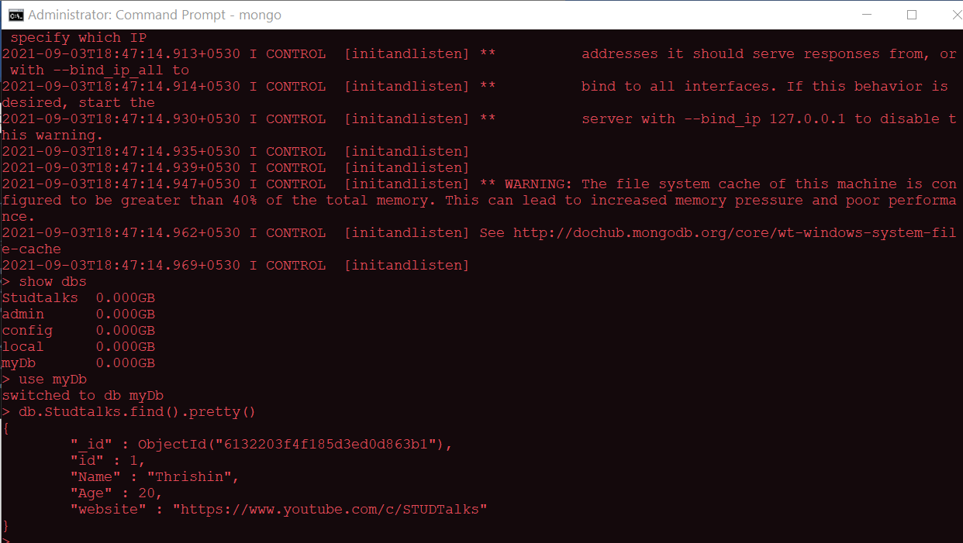

Retrieving data from database

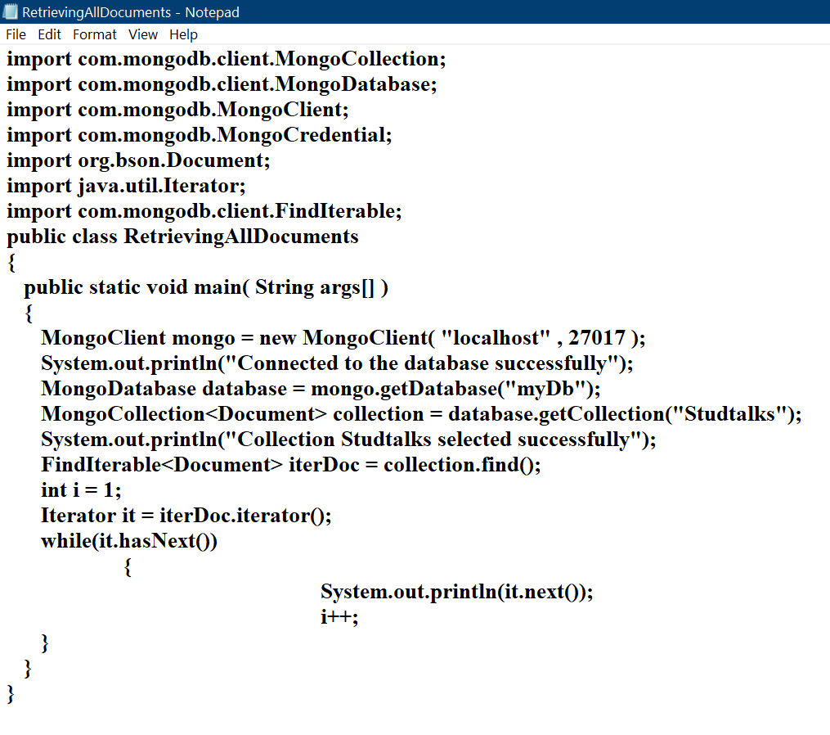

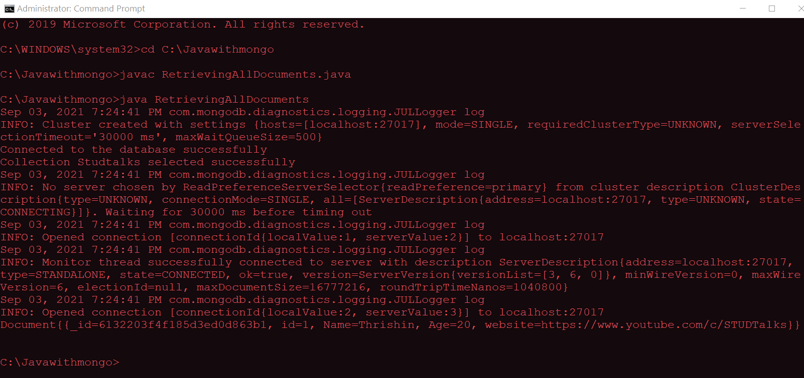

Updating data in database

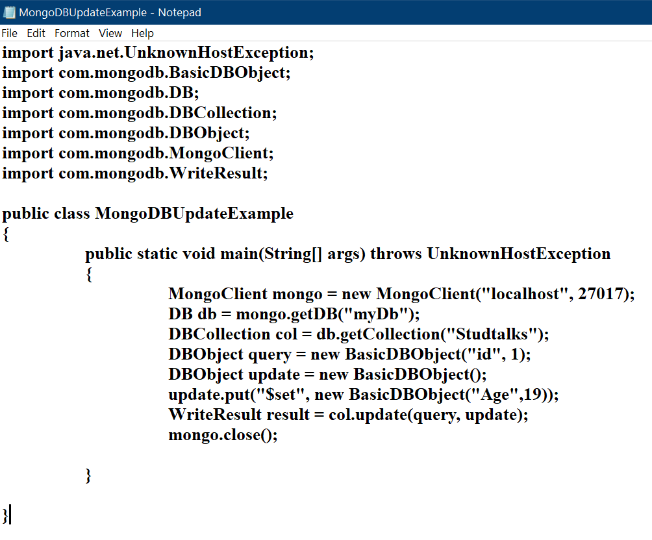

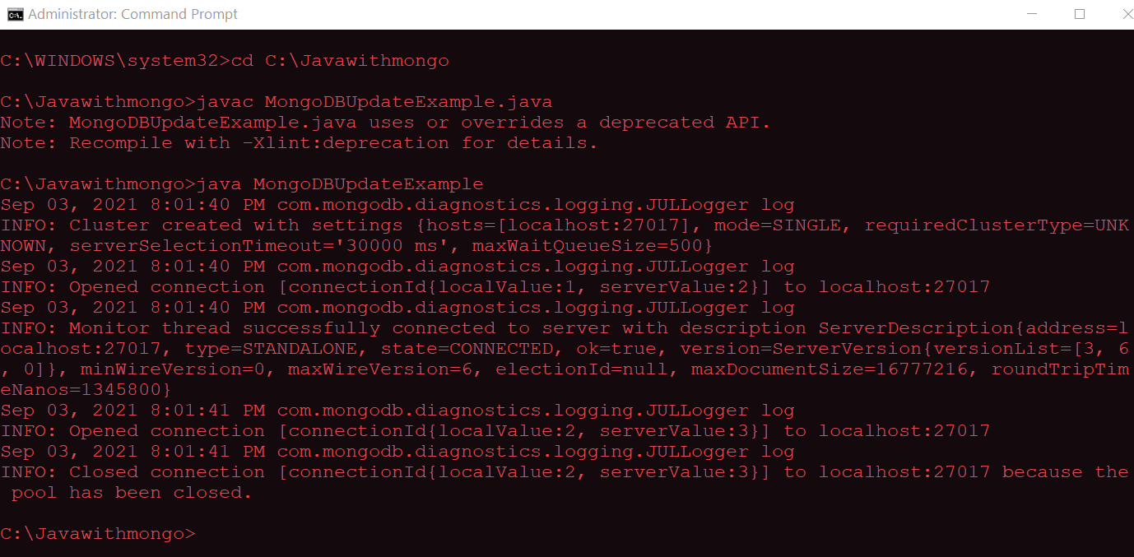

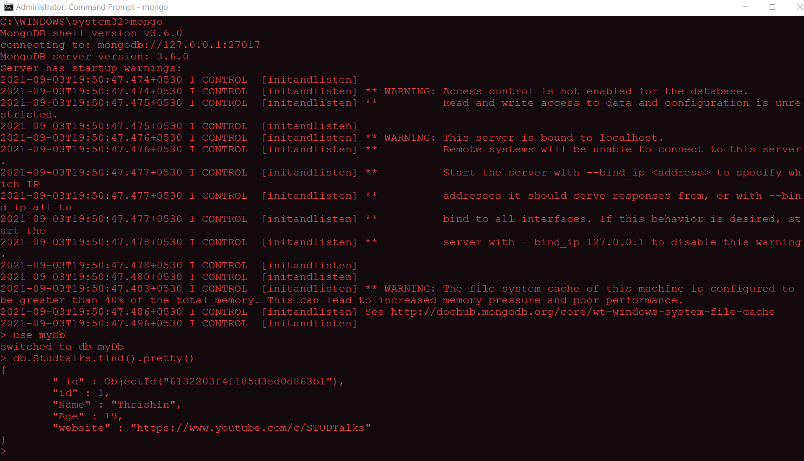

Deleting data from database

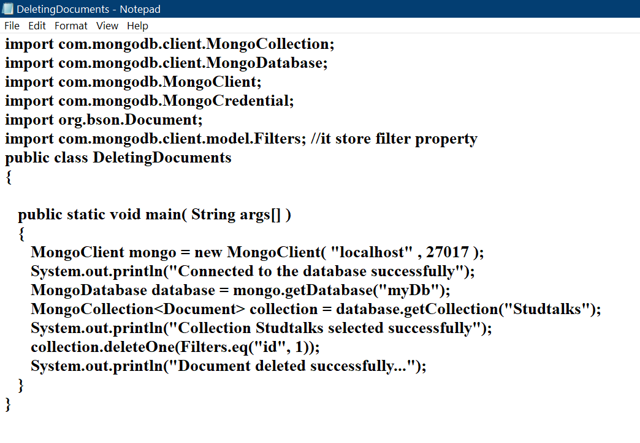

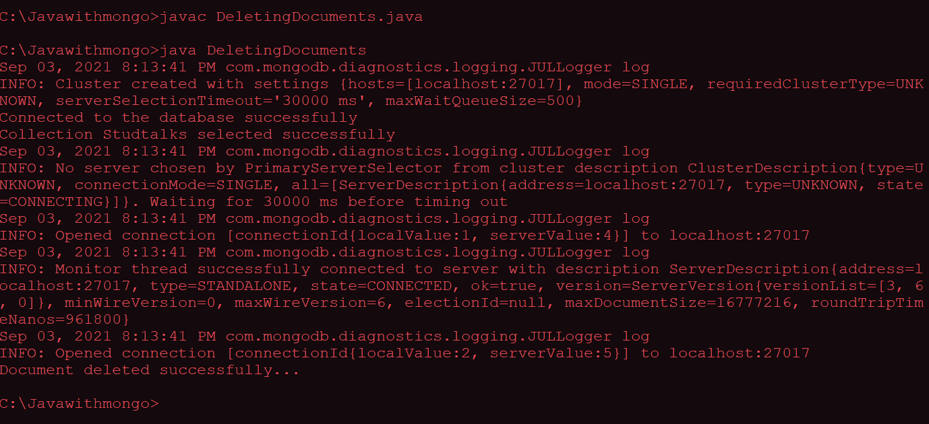

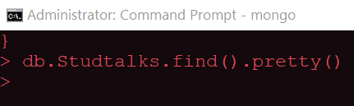

2.

Code:

Collper_1.html

<!DOCTYPE html>

<html>

<head>

</head>

<body>

    <h2>Get data as  JSON from a PHP file on the server</h2>

    <p>The JSON received from the PHP file</p>

    <p id="demo"></p>

    <script>

        var obj,dbParam,xmlhttp;

        obj={"Name":"Json1","Roll":"1234","password":"5678","pincode":"421308"};

        dbParam=JSON.stringify(obj);

        xmlhttp=new XMLHttpRequest();

        xmlhttp.onreadystatechange=function()

        {

            if(this.readyState==4 && this.status==200)

            {

                document.getElementById("demo").innerHTML=this.responseText;

            }

        };

        xmlhttp.open("GET","collpersistence_1.php?x="+dbParam,true);

        xmlhttp.send();

    </script>

</body>

</html>

collpersistence_1.php

<?php

    header("Content-Type:application/json;charset=UTF-8");

    $obj=json_decode($_GET["x"],false);

    $a=$obj->Name;

    $b=$obj->Roll;

    $c=$obj->password;

    $d=$obj->pincode;

    $con=mysql_connect("Localhost","root","");

    if($con)

    {

        echo "connected";

    }

    $db=mysql_select_db("data_1",$con);

    if($db)

    {

        echo "connected";

    }

    $sql="insert into json_1(Name,Roll,password,pincode) values('$a','$b','$c','$d')";

    $z=mysql_query($sql,$con);

    echo json_encode($obj);

?>

Output:

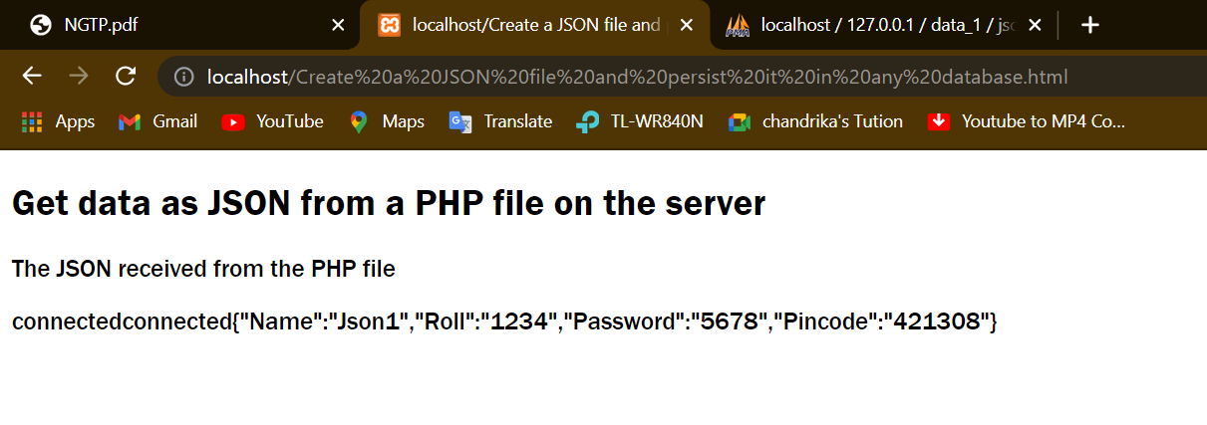

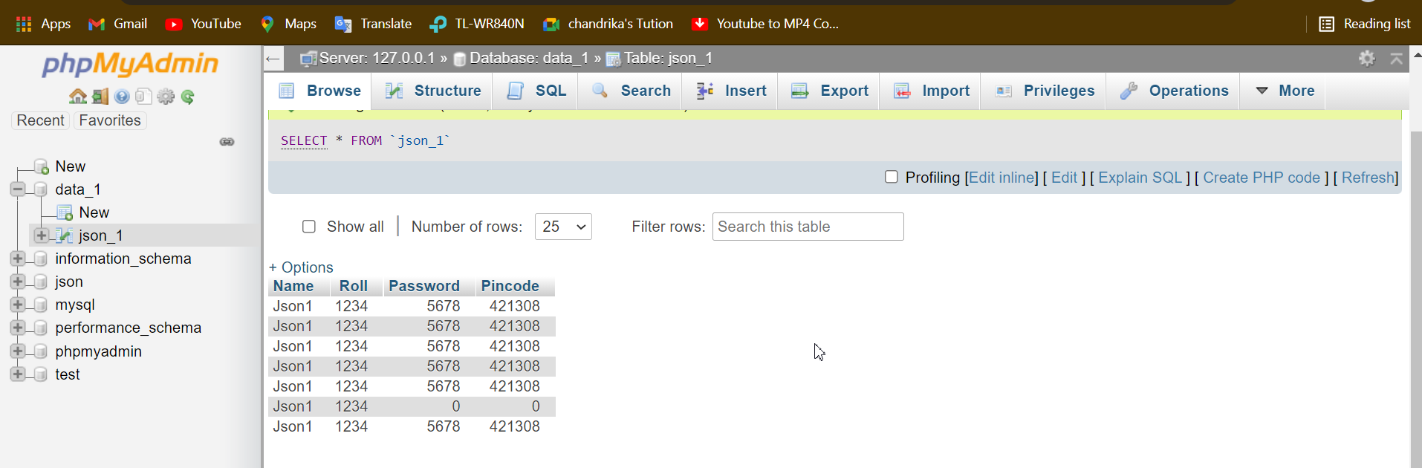

**Slip 3**

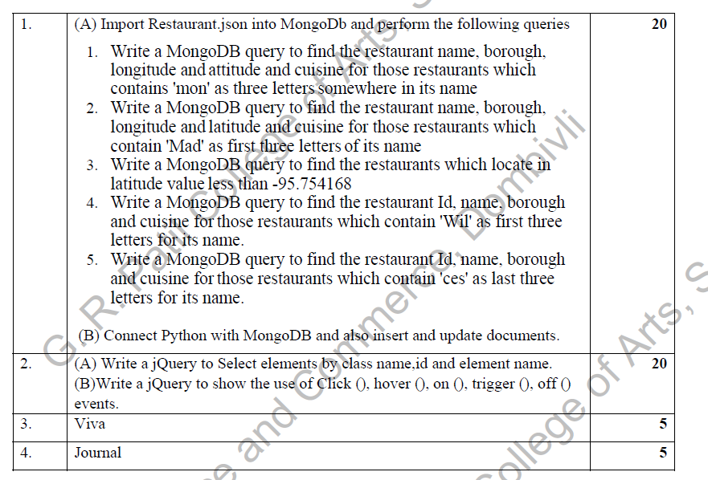

1.

A)

1.

Code:

db.rest.find({name:/.*mon.*/},{"name":1,"borough":1,"address.coord":1,"cuisine":1}).pretty()

Output:

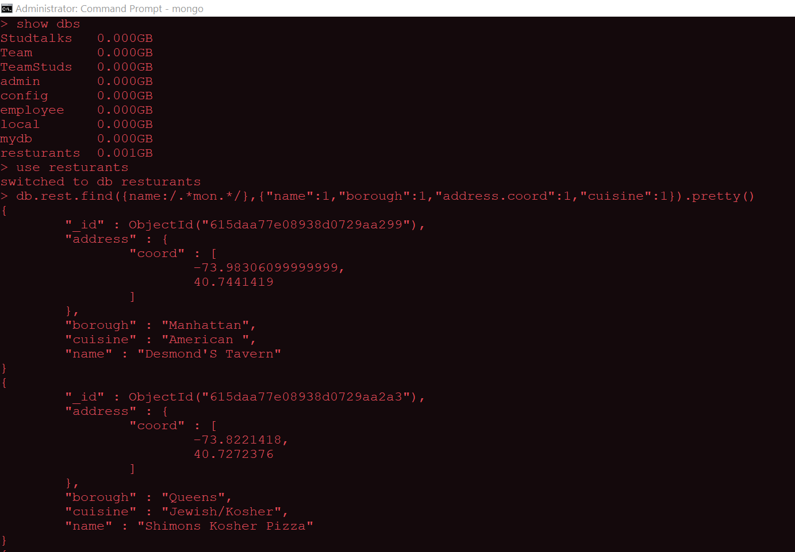

2.

Code:

db.rest.find({name:/^Mad/},{"name":1,"borough":1,"address.coord":1,"cuisine":1}).pretty()

Output:

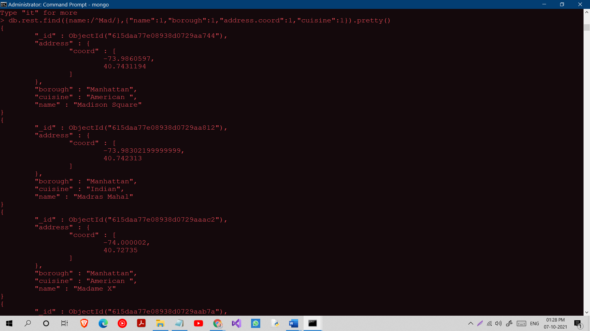

3.

Code:

db.rest.find({"address.coord":{$lt:-95.754168}}).pretty()

Output:

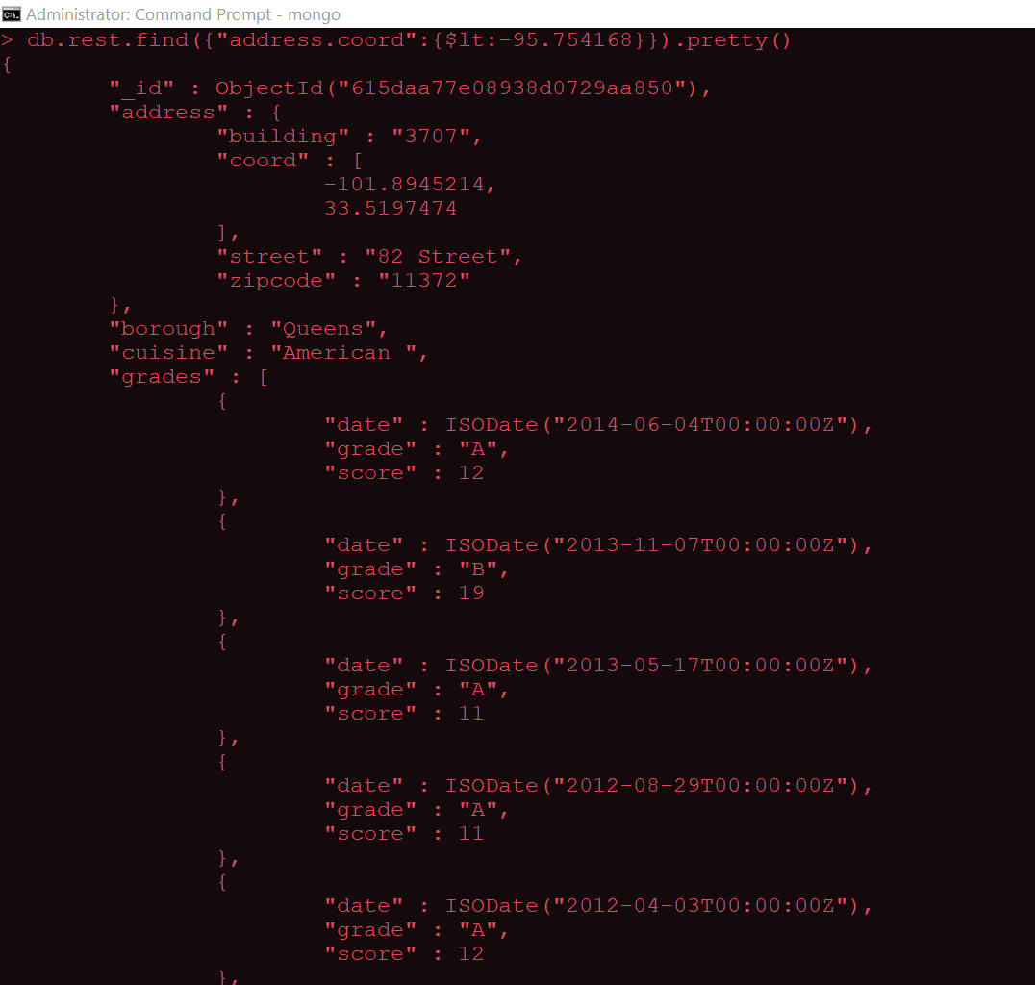

4.

Code:

db.rest.find({name:/^Wil/},{"name":1,"borough":1,"restaurant_id":1,"cuisine":1}).pretty()

Output:

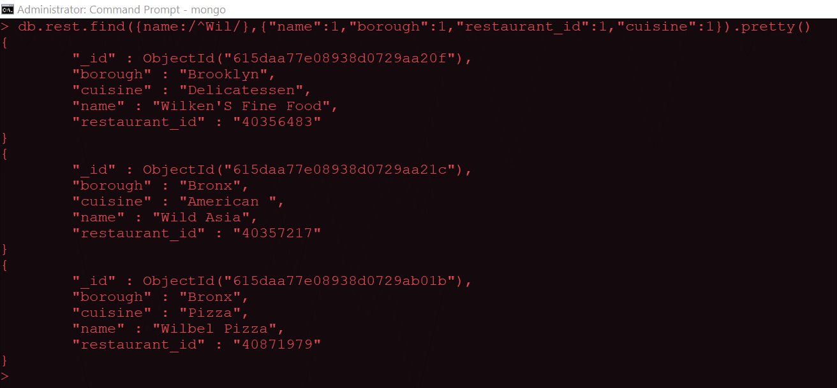

5.

Code:

db.rest.find({name:/ces$/},{"name":1,"borough":1,"restaurant_id":1,"cuisine":1}).pretty()

Output:

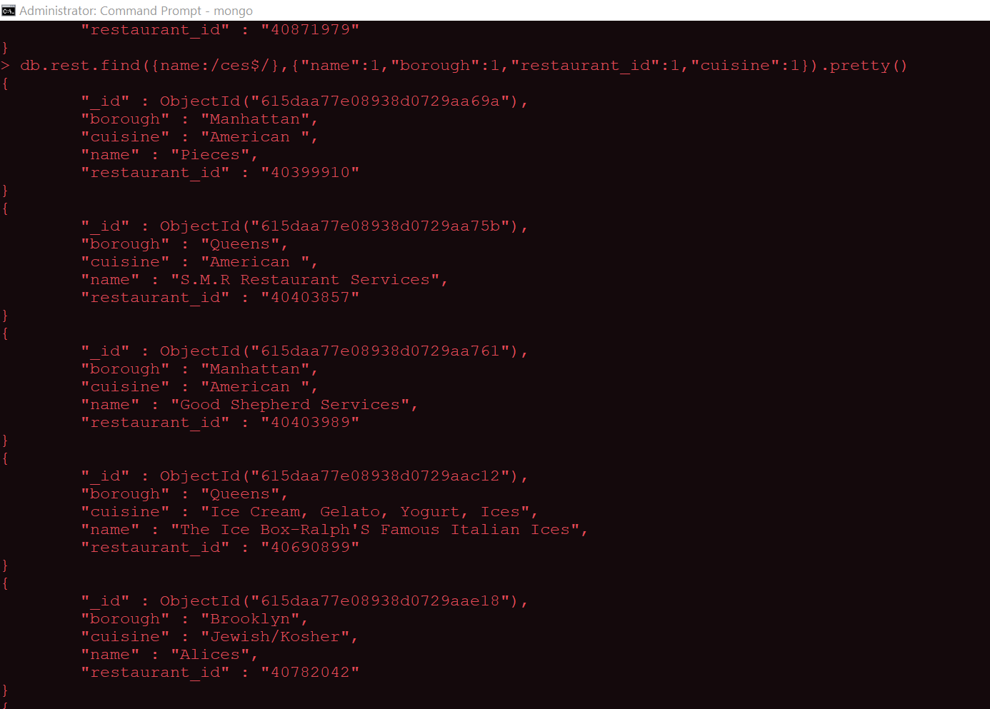

1.B)

a. Insert in python in slip no 1

b. update in python

1) Open CMD and install pymongo using the command **pip install pymongo**

2) Open CMD and type **mongod** and open new CMD, type **mongo** and setup connection

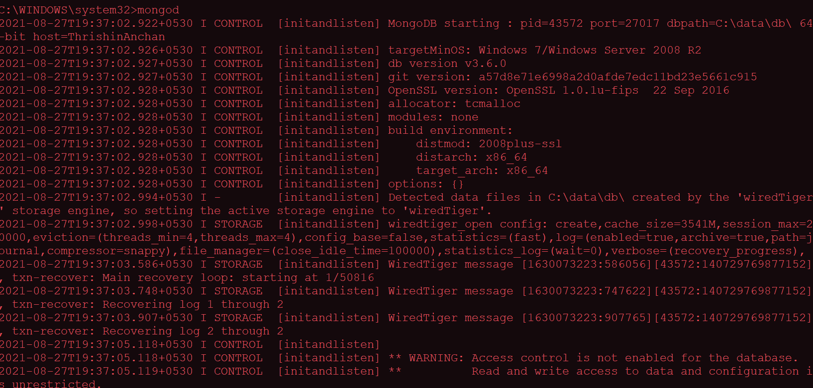

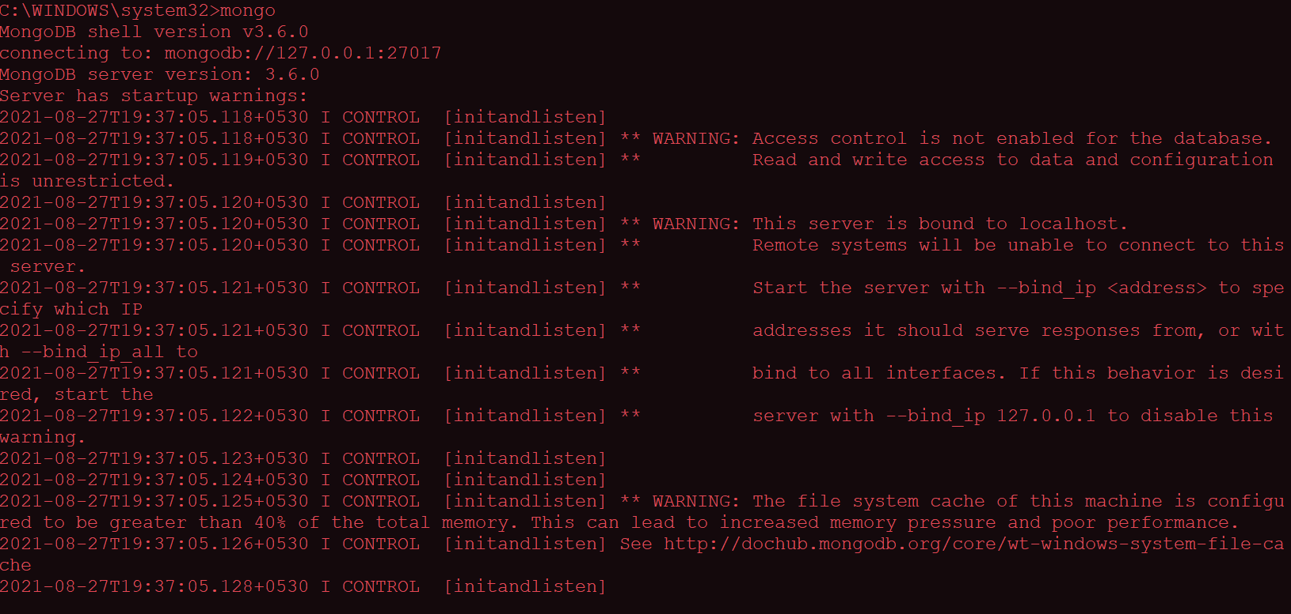

**Python Code:**

Inserting data into database

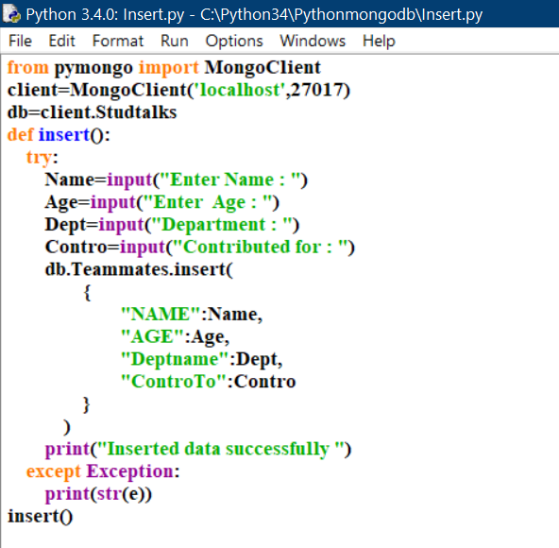

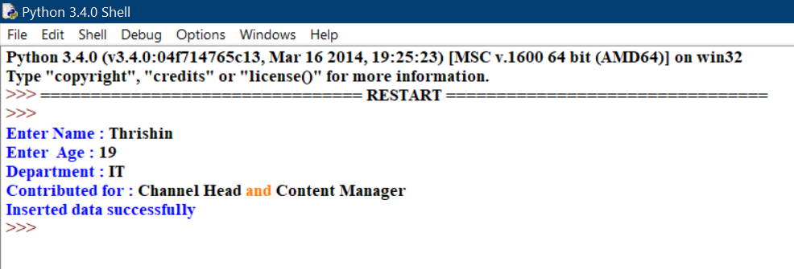

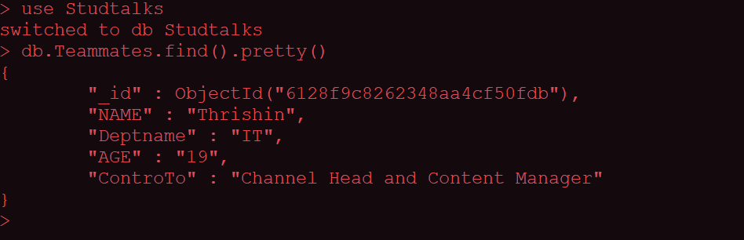

Updating data in database

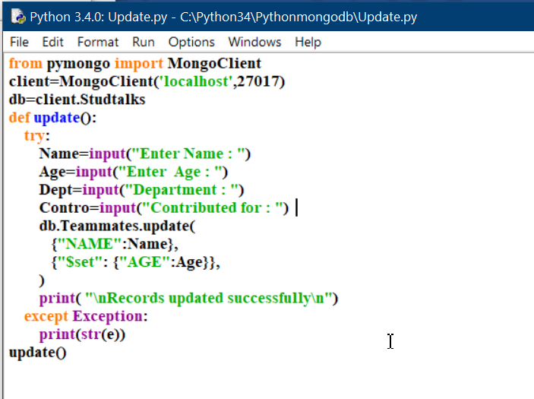

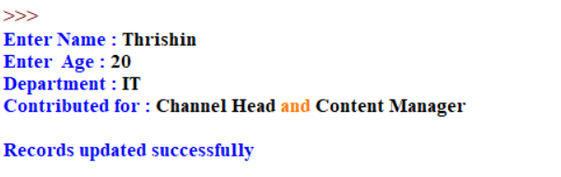

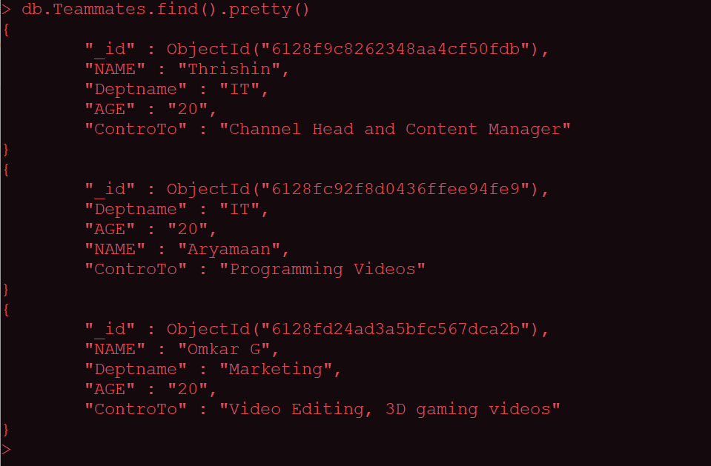

2.A)

Code:

<!DOCTYPE html>

<html>

<head>

    <title></title>

    <script src="jquery-3.6.0.min.js"></script>

    <script>

        $(document).ready(

            function () {

                $(".class1").css("background", "yellow");

                $("#id1").css("background", "pink");

                $("h2").css("background", "green");

            }

        );

    </script>

</head>

<body>

    <p class="class1">Hello!</p>

    <p id="id1">Students</p>

    <h2>welcome in jquery Language!!</h2>

</body>

</html>

Output:

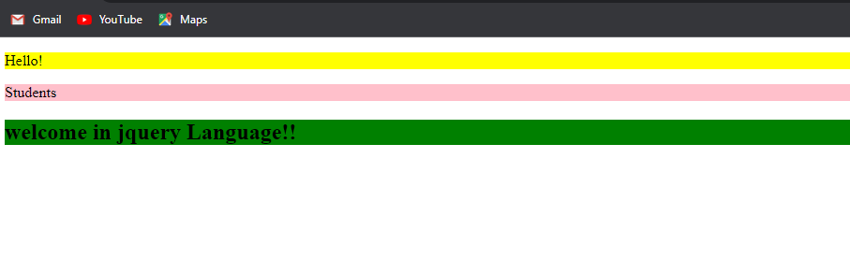

2B)

Code:

<!DOCTYPE html>

<html>

<head>

    <title></title>

    <script src="jquery-3.6.0.min.js"></script>

    <script>

        $(document).ready(

            function () {

                $("#b1").hover(

                    function () {

                        document.write("hello world");

                    }

                );

                $("p").on("click", function () {

                    $(this).css("background-color", "pink");

                }

                );

                $("#b2").click(

                    function () {

                        $("p").off("click");

                    }

                );

                $("#b3").on("click", function () {

                    $("#t1").hide();

                }

                );

                $("input").select(

                    function () {

                        $("input").after(" Text marked!");

                    }

                );

                $("#b4").click(

                    function () {

                        $("input").trigger("select");

                    }

                );

            }

        );

    </script>

</head>

<body>

    <button id="b1">hover</button><br />

    <p>hello welcome in Mulund college of commerce!!</p>

    <p>TYIT students</p>

    <button id="b2">off</button><br /><br />

    <p id="t1">Hello world</p><br />

    <button id="b3">on</button><br /><br />

    <input type="text" value="Hello World"><br><br>

    <button id="b4">trigger</button>

</body>

</html>

Output:

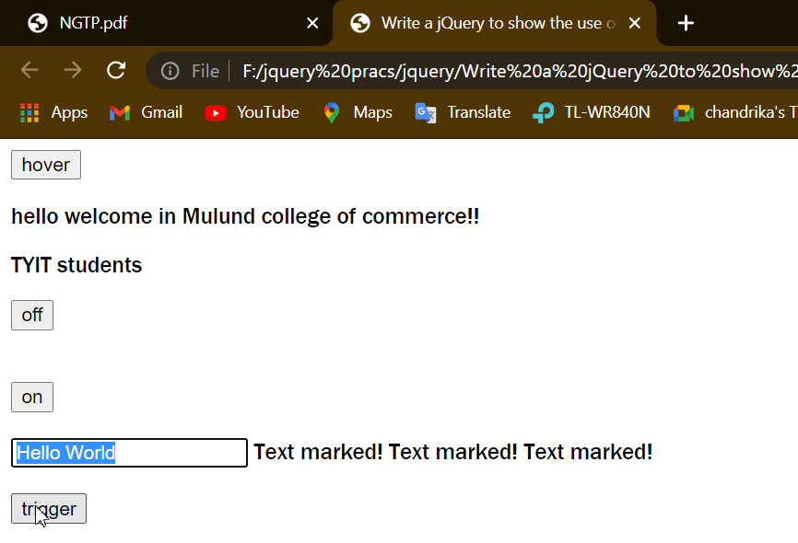

**Slip 4:**



1.

Inserting data into database

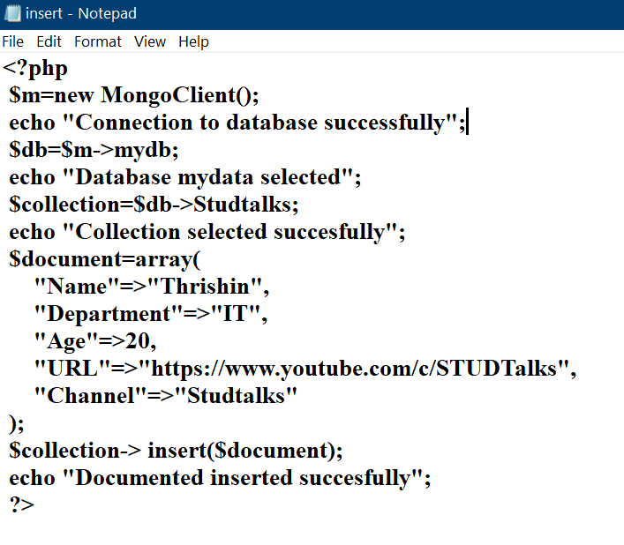

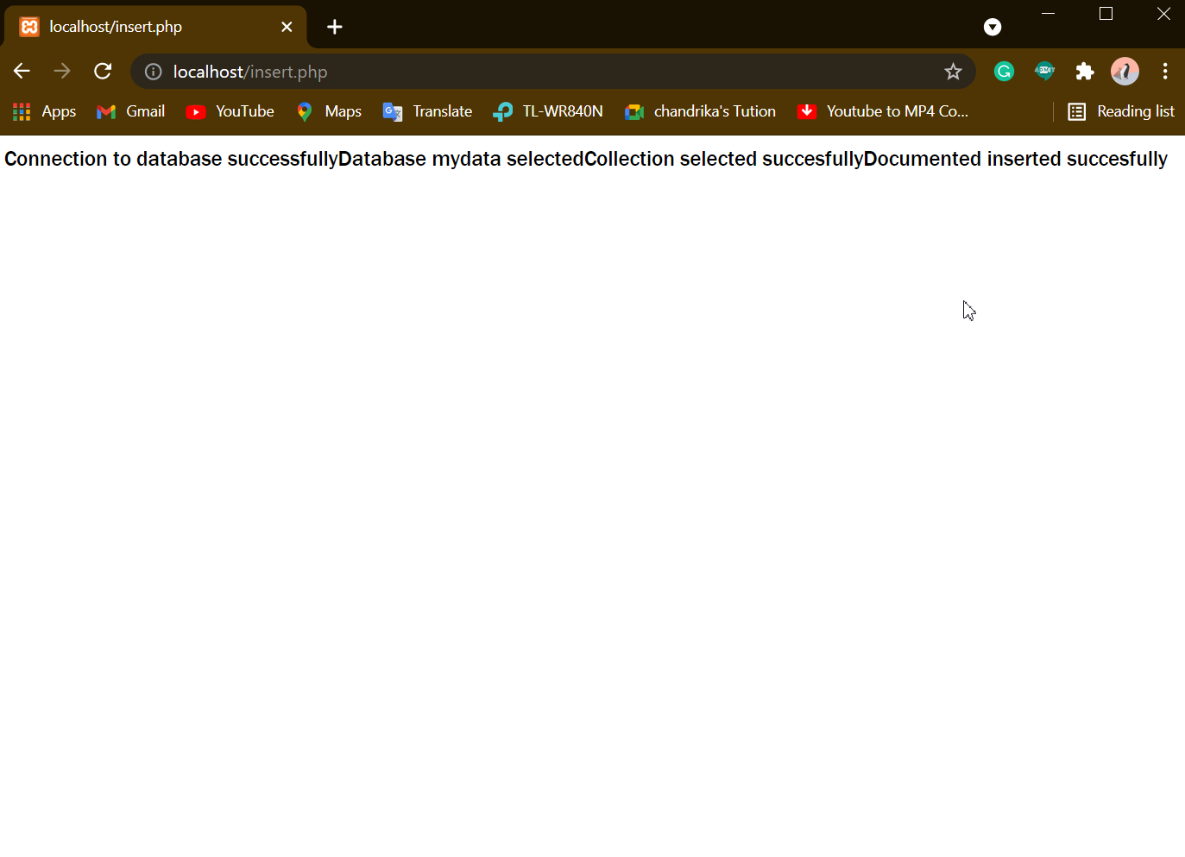

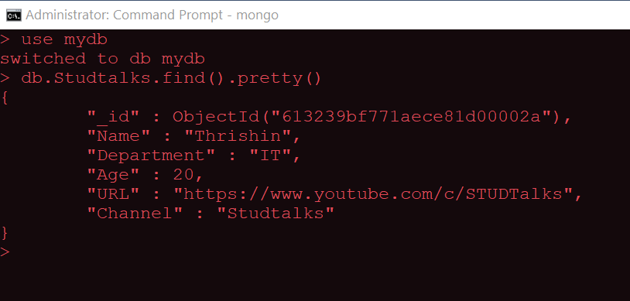

Updating data in database

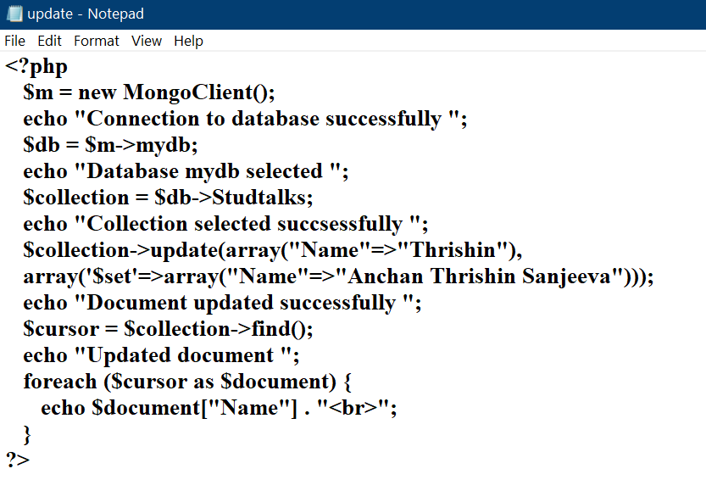

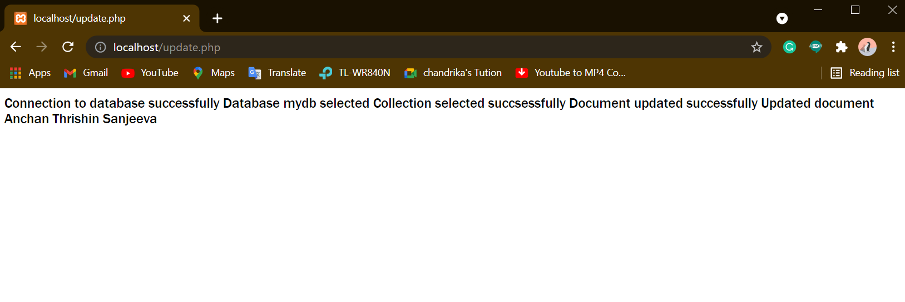

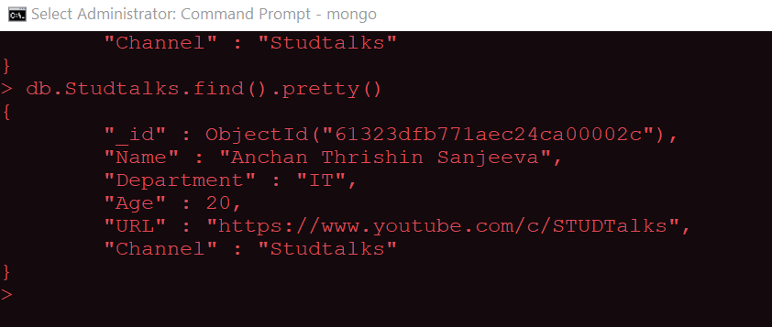

Retrieving data from database

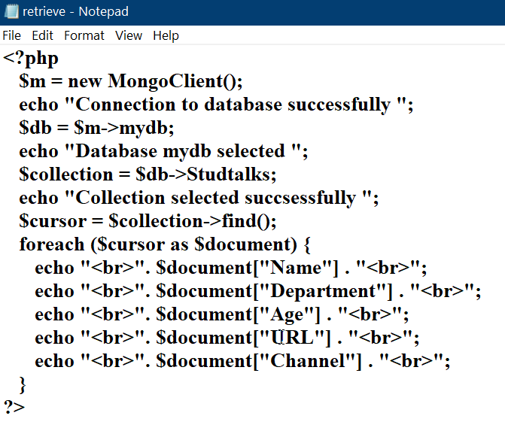

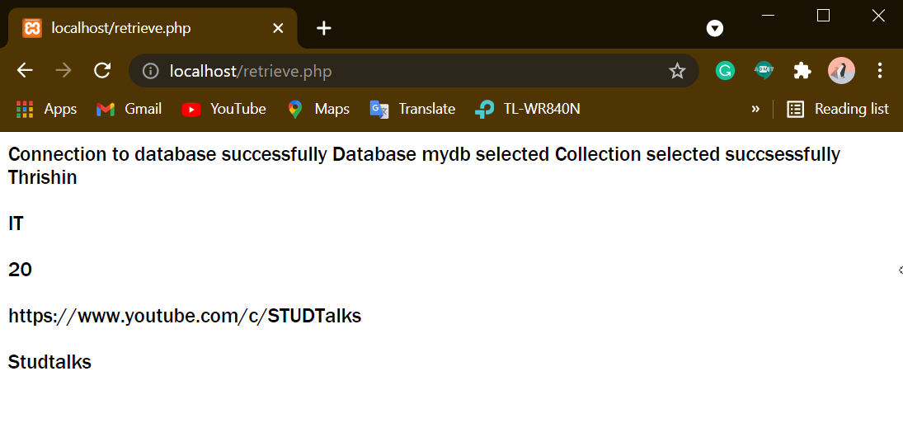

Deleting data from database

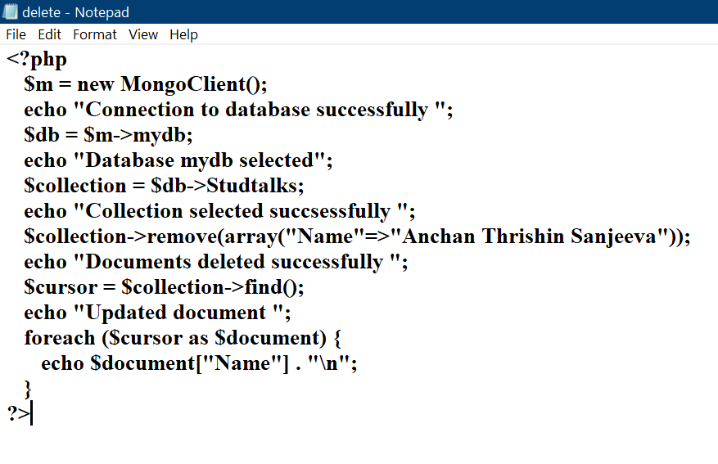

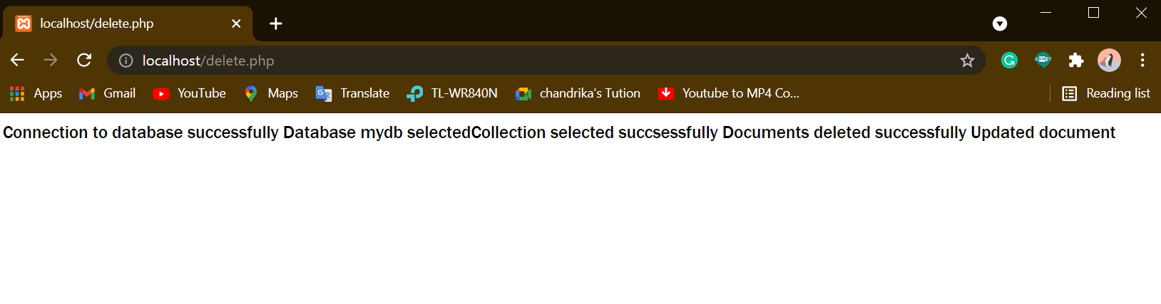

2.A)

Code:

html>

<head>

<title>parsing</title>

</head>

<body>

<script type="text/javascript">

    var data='{"name":"Ravi","id":5,"Gender":"male"}';

    var json_obj=JSON.parse(data,function(name,value)

                    {

                        return value;

                    }

                );

    document.writeln(json_obj.name);

    for(key in json_obj)

    {

        document.write("</br>"+key+ ":" +json_obj[key]);

    }

    var json_obj=JSON.parse(data,function(name,value)

                    {

                        if(name=="id")

                        {

                            return undefined;

                        }

                        else

                        {

                            return value;

                        }

                    }

                );

    for(key in json_obj)

    {

        document.write("</br>"+key+ ":" +json_obj[key]);

    }

</script>

</body>

</html>

Output:

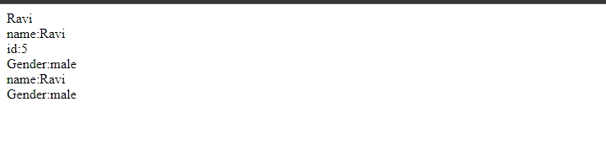

B)

Code:

<!DOCTYPE html>

<html>

<head>

    <title></title>

    <script src="jquery-3.6.0.min.js"></script>

    <script>

        $(document).ready(

            function () {

                $(".up-btn").click(

                    function () {

                        $("p").slideUp();

                    }

                );

                $(".down-btn").click(

                    function () {

                        $("p").slideDown();

                    }

                );

                $(".toggle-btn").click(

                    function () {

                        $("p").slideToggle();

                    }

                );

            }

        );

    </script>

</head>

<body>

    <button type="button" class="up-btn">Slide Up Paragraphs</button>

    <button type="button" class="down-btn">Slide Down Paragraphs</button>

    <button type="button" class="toggle-btn">Slide Toggle Paragraphs</button>

    <p>This is a paragraph.</p>

    <p>This is another paragraph.</p>

</body>

</html>

Output:

Slide Up:

It will slide up or hide

Slide down :

It will come or it will show

Toggle:

It will hide and show

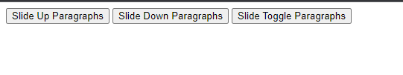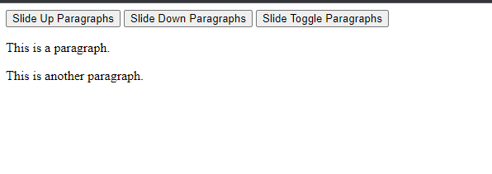

**Slip 5**

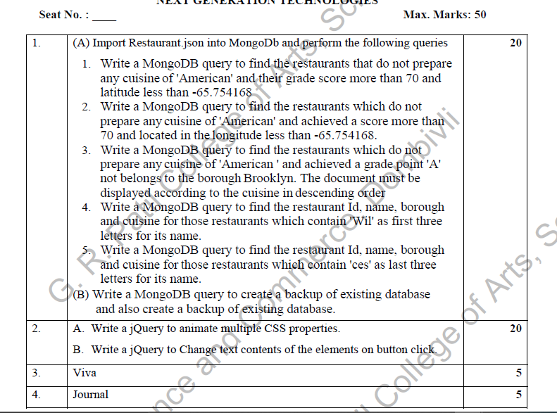

1.A)

1.

Code:

db.rest.find( {$and: [ {"cuisine" : {$ne :"American "}}, {"grades.score" : {$gt : 70}}, {"address.coord" : {$lt : -65.754168}} ] } ).pretty()

Output:

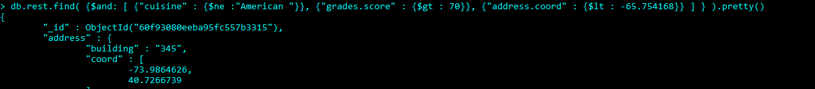

2.

db.rest.find( { "cuisine" : {$ne : "American "}, "grades.score" :{$gt: 70},"address.coord" : {$lt : -65.754168} } ).pretty()

Output:

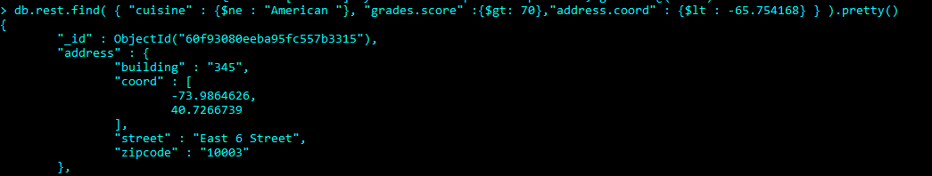

3.

db.rest.find( { "cuisine" : {$ne : "American "}, "grades.grade" :"A", "borough": "Brooklyn" } ).sort({"cuisine":-1}).pretty()

Output:

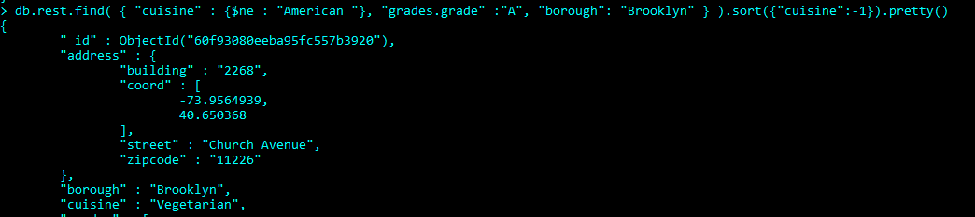

4.

Slip no 3

5.

Slip no 3

1.B)

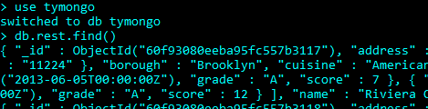

To delete the database

Again open the command prompt type mongodump

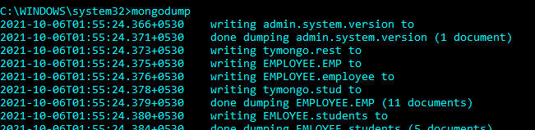

In mongo type db.dropDatabase()



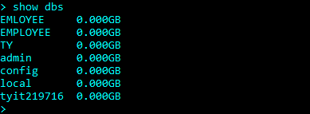

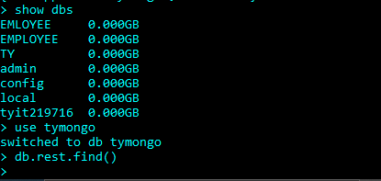

How to backup

To backup type mongorestore

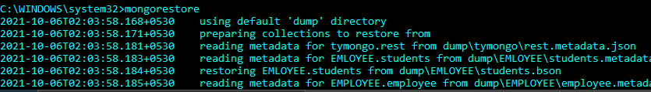

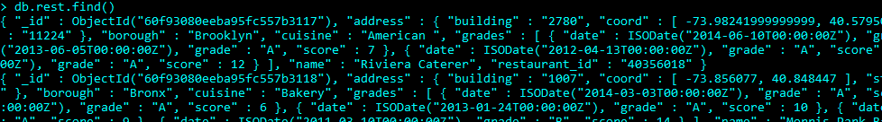

Now see all the files have restore

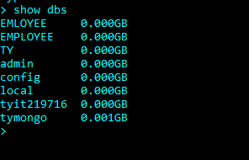

tymongo as restore

if you want to restore another database use have to switch the another database and type in another command prompt mongorestore like have done about the database TY

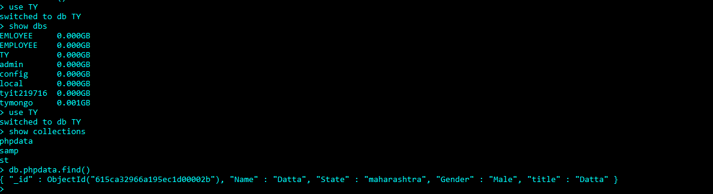

2.A)

Code:

Slip no 1

B)

Code:

<!DOCTYPE html>

<html>

<head>

    <title></title>

    <script src="jquery-3.6.0.min.js"></script>

    <script>

        $(document).ready(

            function () {

                $("button").click(

                    function () {

                        document.write("hello world");

                    }

                );

            }

        );

    </script>

</head>

<body>

    <p>Hello! Welcome in Jquery Language!!</p>

    <button>Click me</button>

</body>

</html>

Output:

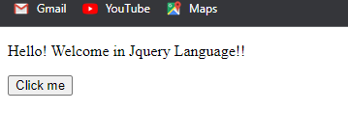

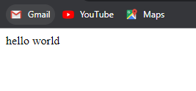

**Slip 6:**



**1.**

**Server 1**

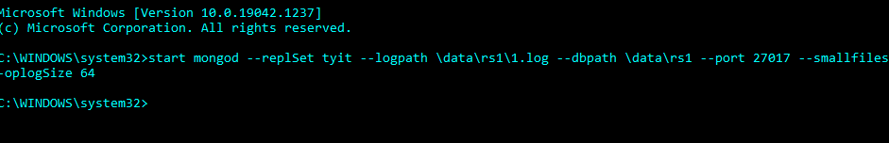

**Server 2**

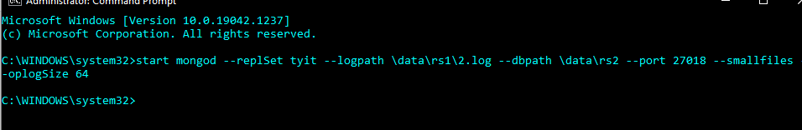

**Server 3**

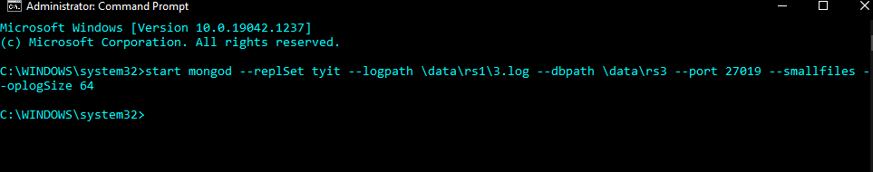

**Port of server 1**

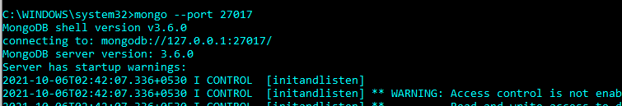

**Port of server 2**

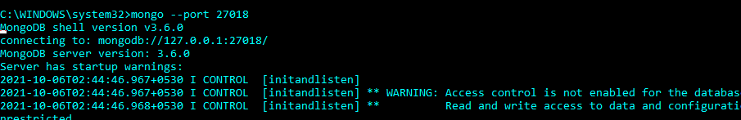

**Port of server 3**

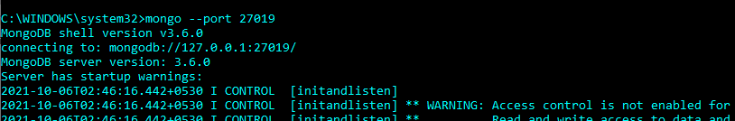

**Configuration**

**On server 1**

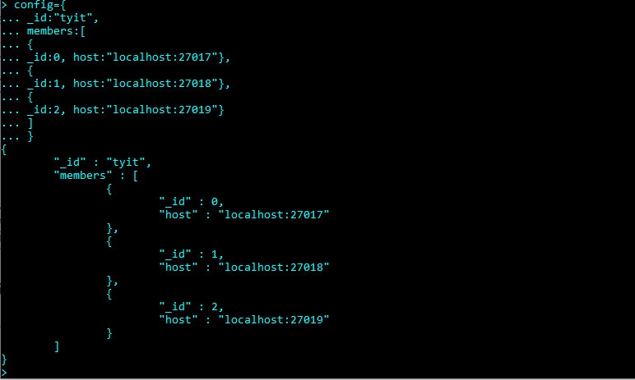

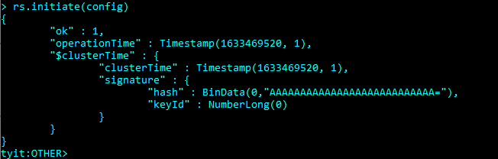

**Server 2 and Server 3**

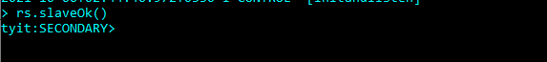

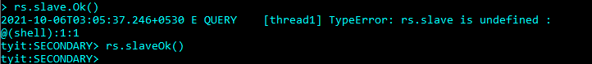

**We have to insert the documents**

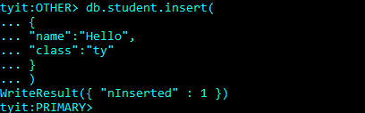

**Now we will see the secondary server also have inserted the documents**

**Server 2**

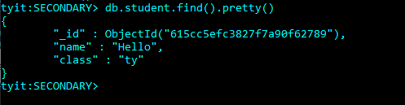

**Server 3:**

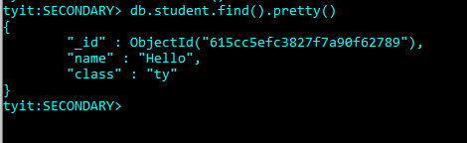

**Now we will delete 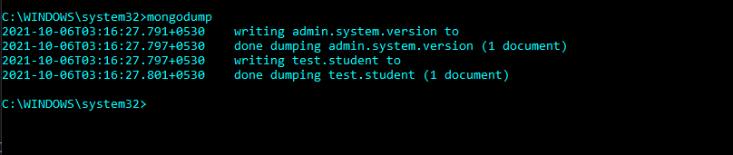the records and database**

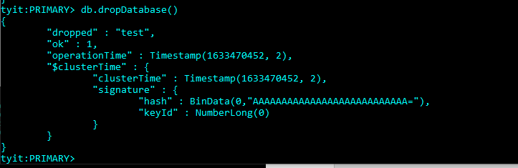

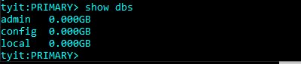

**All the record is deleted from the database and collections from primary and the secondary server**

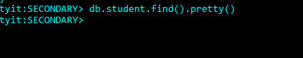

**Now we will restore the database and collections**

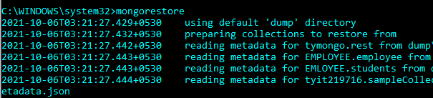

**We have backup the collections**

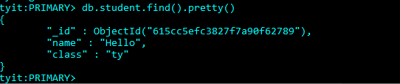

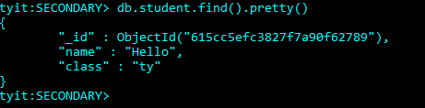

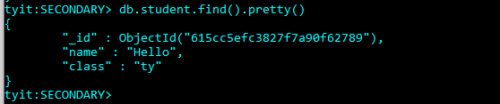

2.A)

Code:

<!DOCTYPE html>

<html>

<head>

    <title></title>

    <script src="jquery-3.6.0.min.js"></script>

    <script>

        $(document).ready(

            function () {

                $("button").click(

                    function () {

                        $("p").removeClass("intro");

                    }

                );

            }

        );

    </script>

    <style>

        .intro {

            font-size: 120%;

            color: red;

        }

    </style>

</head>

<body>

    <h1>This is a heading</h1>

    <p class="intro">This is a paragraph.</p>

    <p class="intro">This is another paragraph.</p>

    <button>Remove the "intro" class from all p elements</button>

</body>

</html>

Output:

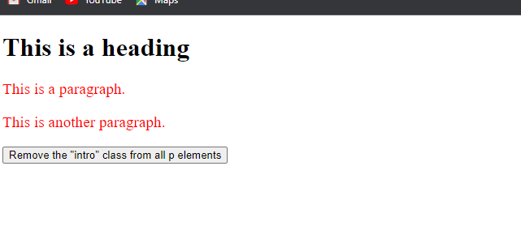

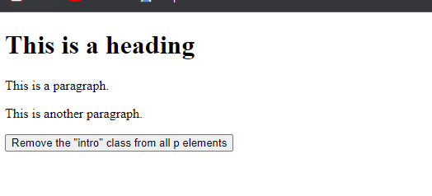

B)

Code:

<!DOCTYPE html>

<html>

<head>

    <title></title>

    <script src="jquery-3.6.0.min.js"></script>

    <script>

        $(document).ready(

            function () {

                $(".b1").click(

                    function () {

                        $(".box").slideToggle();

                    }

                );

            }

        );

    </script>

</head>

<body>

    <button type="button" class="b1">Slide Toggle</button>

    <hr>

    <div class="box">

        <div class="box-inner">Lorem ipsum dolor sit amet, consectetur adipiscing elit. Nam eu sem tempor, varius quam

            at, luctus dui. </div>

    </div>

</body>

</html>

**Output:**

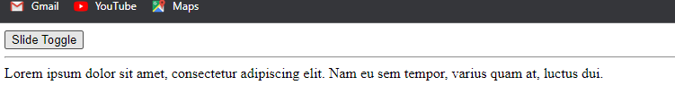

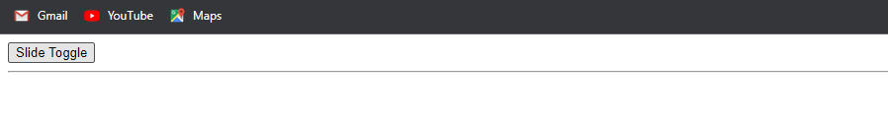

**Slip 7**

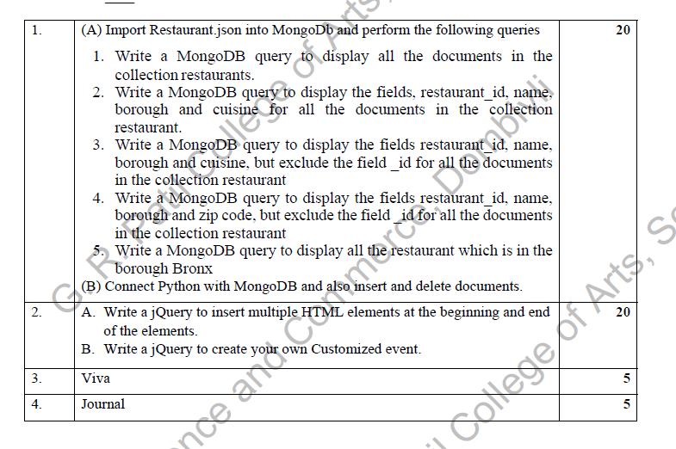

1.A)

1.

Code:

Slip no 1

2.

code:

slip no 1

3, and 4. And 5

Code:

Slip no 1

!.B)

Insert

Slip no 1

Delete

Code:



from pymongo import MongoClient

client=MongoClient('localhost:27017')

db=client.TY

def delete():

try:

name=input("\n Enter the Name: ")

db.st.remove(

{"Name":name}

)

print("\n Deletion successfully \n ")

except (Exception):

print(str(e))

delete()

Output:

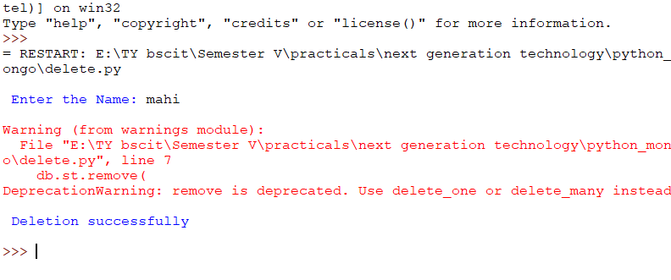



2.

A)

Code:

<!DOCTYPE html>

<html>

<head>

    <title></title>

    <script src="jquery-3.6.0.min.js"></script>

    <script>

        $(document).ready(

            function () {

                $(".b1").click(

                    function () {

                        var newHeading = "<h1>Important Note:</h1>";

                        var newParagraph = document.createElement("p");

                        newParagraph.innerHTML = "<em>hello world</em>";

                        $("body").append(newHeading, newParagraph);

                    }

                );

            }

        );

    </script>

</head>

<body>

    <button class="b1">Insert Contents</button>

    <p>Lorem ipsum dolor sit amet, consectetur adipiscing elit. </p>

</body>

</html>

Output:

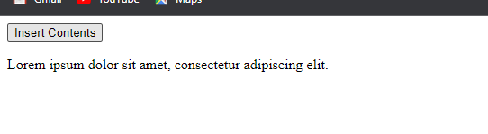

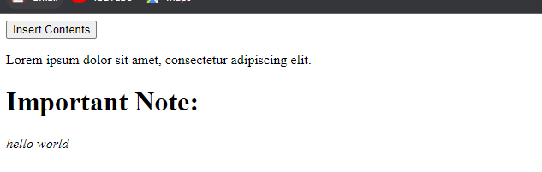

B) part to own customized you can choose the any element of the event in jquery

**Slip no : 8**



1.

Code:

Slip no 1,3,7

2.

Slip no 2

**Slip no :9**

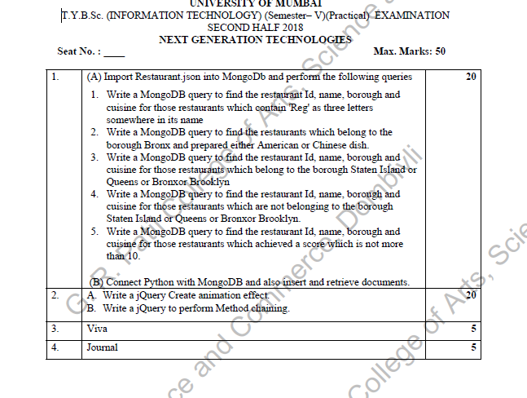

**1**.A

1.

Code

Slip no 3 only difference is write Reg delete mon

2.

Code:

db.rest.find( { "borough": "Bronx" , $or : [ { "cuisine" : "American " }, { "cuisine" : "Chinese" }] } ).pretty()

Output:

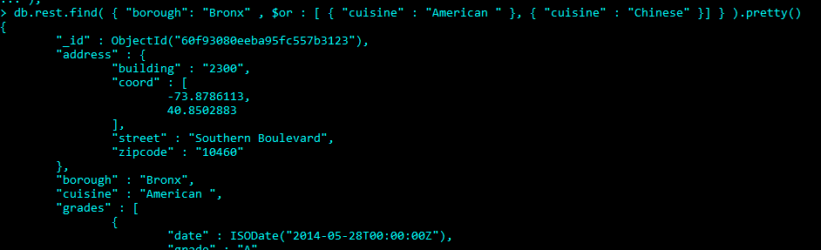

3.

Code:

db.rest.find( {"borough" :{$in :["Staten Island","Queens","Bronx","Brooklyn"]}}, { "restaurant_id" : 1, "name":1,"borough":1, "cuisine" :1 } ).pretty()

Output:

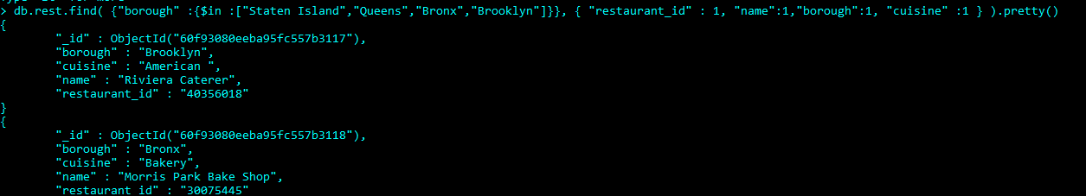

4.

Code:

db.rest.find( {"borough" :{$nin :["Staten Island","Queens","Bronx","Brooklyn"]}}, { "restaurant_id" : 1, "name":1,"borough":1, "cuisine" :1 } ).pretty()

Output:

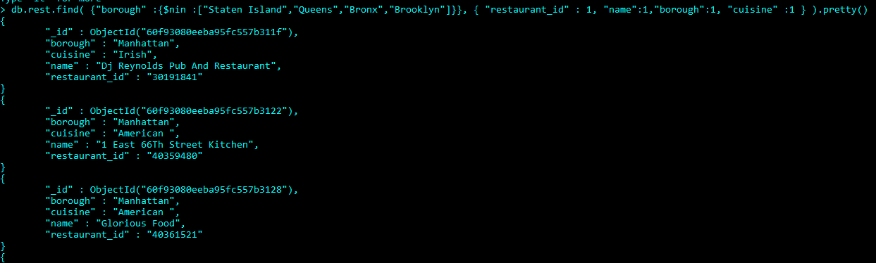

5,

Code:

db.rest.find( {"grades.score" : { $not: {$gt : 10} } }, { "restaurant_id" : 1, "name":1,"borough":1, "cuisine" :1 } ).pretty()

Output:

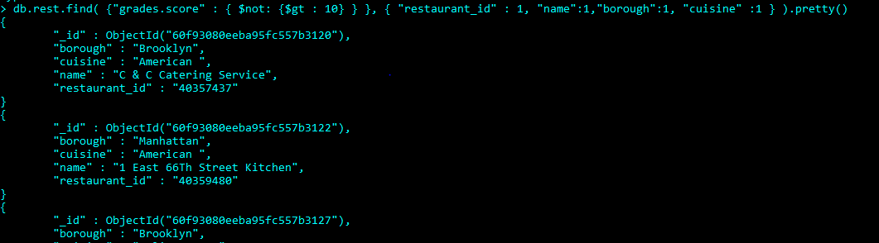

2.A)

Code:

<!DOCTYPE html>

<html>

<head>

    <title></title>

    <script src="jquery-3.6.0.min.js"></script>

    <style>

        img {

            position: relative;

            /* Required to move element */

        }

    </style>

    <script>

        $(document).ready(

            function () {

                $("button").click(

                    function () {

                        $("img").animate({ left: 300 });

                    }

                );

            }

        );

    </script>

</head>

<body>

    <button>Start Animation</button><br />

    <img src="A.jpg" alt="Mushroom">

</body>

</html>

Output:



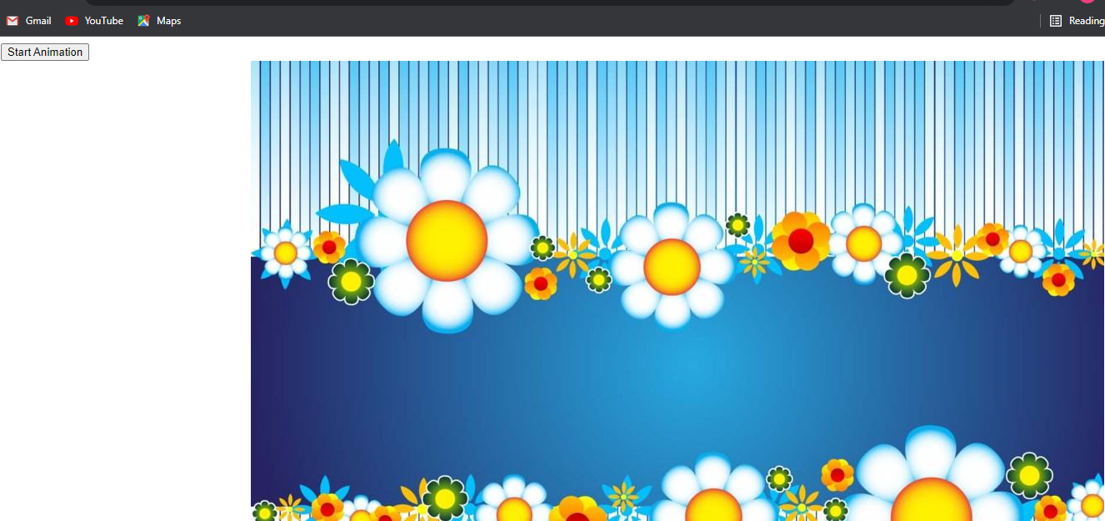

2.B)

Code:

<!DOCTYPE html>

<html>

<head>

    <title></title>

    <script src="jquery-3.6.0.min.js"></script>

    <script>

        $(document).ready(

            function () {

                $("button").click(

                    function () {

                        $("#p1").css("color", "red").slideUp(2000).slideDown(2000);

                    }

                );

            }

        );

    </script>

</head>

<body>

    <p id="p1">Welcome in jQuery!!</p>

    <button>Click me</button>

</body>

</html>

Output:

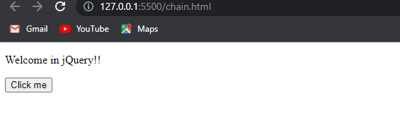

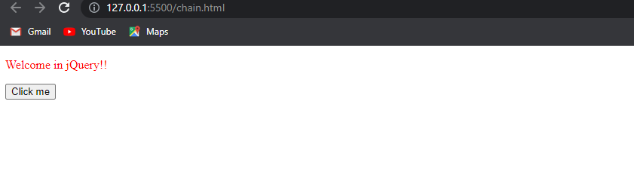

**Slip no 10:**

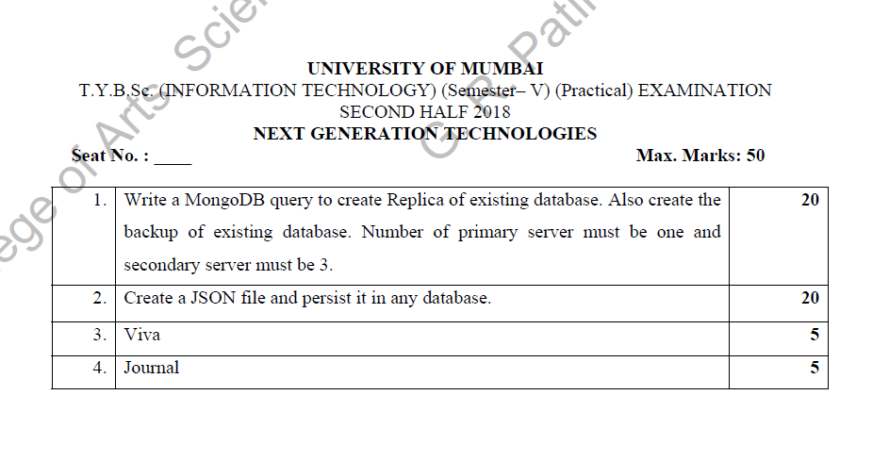

1.

Slip no 6

There was secondary server 2 only you have to create one extra server only all are the same

2.

Slip no 2

**Slip no 11**



1.A)

Code:

db.rest.find( {$or: [ {name: /^Wil/}, {"$and": [ {"cuisine" : {$ne :"American "}}, {"cuisine" : {$ne :"Chinees"}} ]} ]} ,{"restaurant_id" : 1,"name":1,"borough":1,"cuisine" :1} ).pretty()

Output:

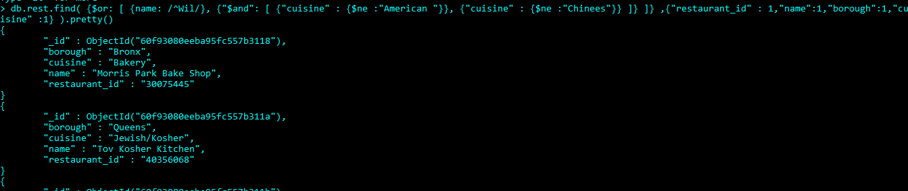

Code:

db.rest.find( {"grades.date": ISODate("2014-08-11T00:00:00Z"), "grades.grade":"A" , "grades.score" : 11 }, {"restaurant_id" : 1,"name":1,"grades":1} ).pretty()

Output:

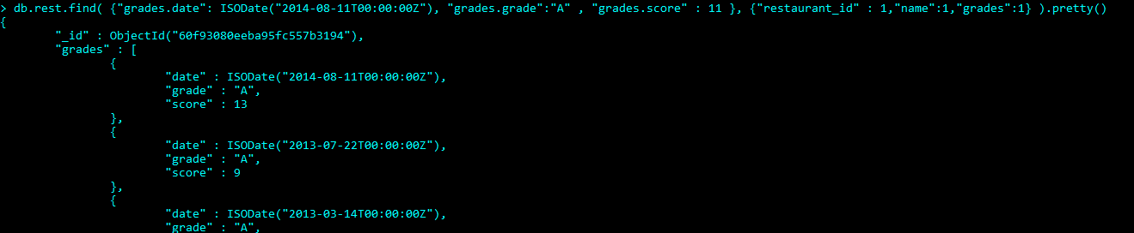

Code:

db.rest.find( { "grades.1.date": ISODate("2014-08-11T00:00:00Z"), "grades.1.grade":"A" , "grades.1.score" : 9 }, {"restaurant_id" : 1,"name":1,"grades":1} ).pretty()

Output:

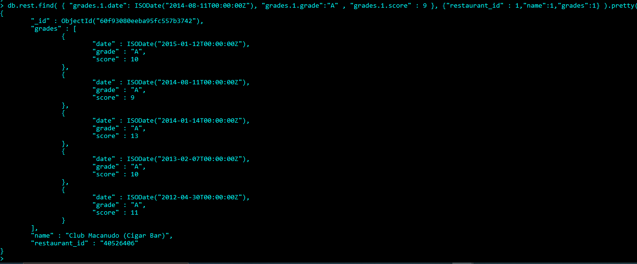

Code;

db.rest.find( { "address.coord.1": {$gt : 42, $lte : 52} }, {"restaurant_id" :1,"name":1,"address":1,"coord":1}).pretty()

output;

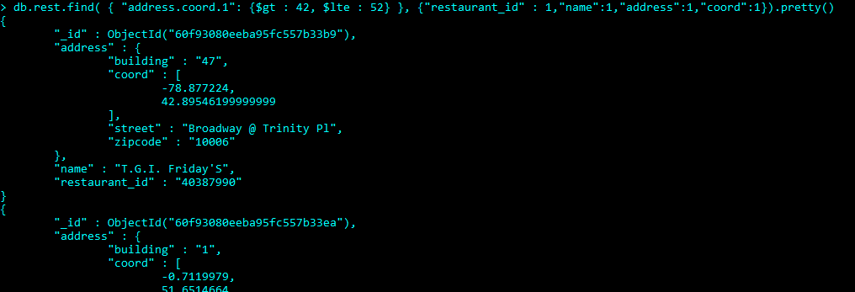

Code:

db.rest.find().sort({"name":1}).pretty()

Output:

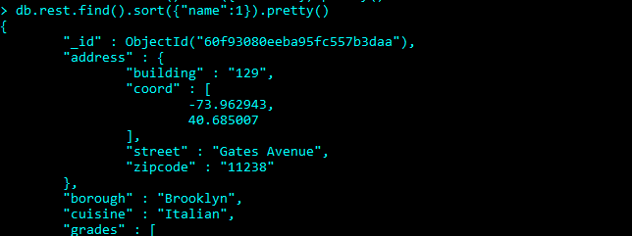

1.B)

Code:

Slip no 7

2.

Code

Slip no 2

**Slip no 12**



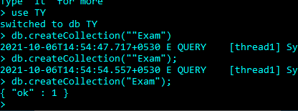

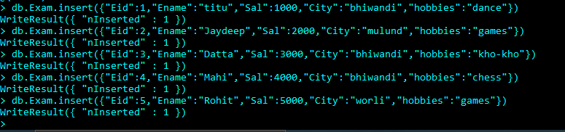



**Queries**

**1.**

**A.**

**Sum:**

**Code:**

**db.Exam.aggregate([{$group: {_id : "$Ename",no: {$sum :1}}}])**

**Output:**

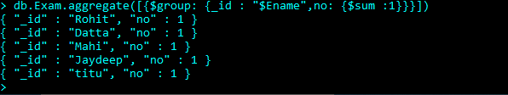

**it will count the name**

**B.**

**Avg**

**Code:**

**db.Exam.aggregate([{$group: {_id : "$Eid",no: {$avg :1}}}])**

**Output:**

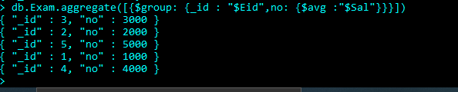

**Min**

**Code:**

**db.Exam.aggregate([{$group: {_id : "$Eid",no: {$min :"$Sal"}}}])**

**Output:**

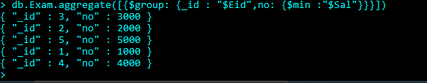

**Max:**

**Code:**

**db.Exam.aggregate([{$group: {_id : "$Eid",no: {$max :"$Sal"}}}])**

**Output:**

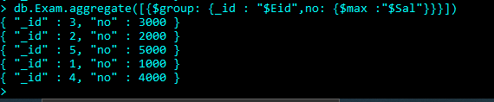

B.

Push

Code:

db.Exam.aggregate([{$group: {_id : "$Eid",hobbies: {$push :"$hobbies"}}}])

Output:

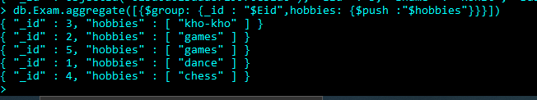

addToSet

Code:

db.Exam.aggregate([{$group: {_id : "$Eid",hobbies: {$addToSet :"$hobbies"}}}])

Output:

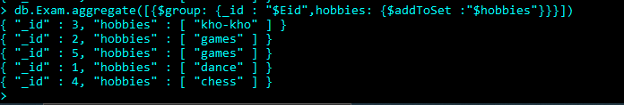

C.

First expression

Code;

db.Exam.aggregate([{$group: {_id : "$Eid",first_hobbies: {$first :"$hobbies"}}}])

Output:

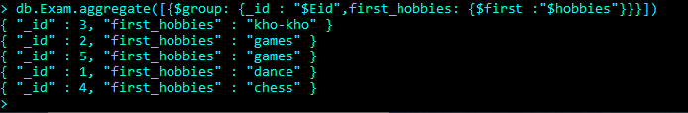

Last expression:

Code:

db.Exam.aggregate([{$group: {_id : "$Eid",last_hobbies: {$last :"$hobbies"}}}])

Output:

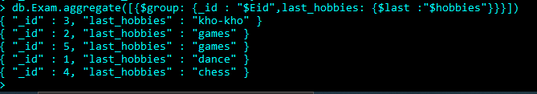

D.

Slip no 5 1B same of the backup of data

2.A

Slip no 4

2.B

Code:

<!DOCTYPE html>

<html>

<head>

    <title></title>

    <script src="jquery-3.6.0.min.js"></script>

    <script>

        $(document).ready(

            function () {

                $(".btn1").click(

                    function () {

                        $("p").fadeOut()

                    }

                );

                $(".btn2").click(

                    function () {

                        $("p").fadeIn();

                    }

                );

            }

        );

    </script>

</head>

<body>

    <p>Mulund College Of Commerce</p>

    <button class="btn1">Fade out</button>

    <button class="btn2">Fade in</button>

</body>

</html>

Output:

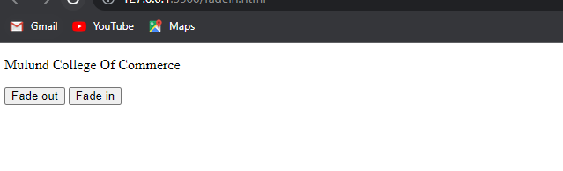

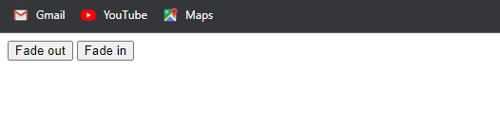

**Slip no 13**

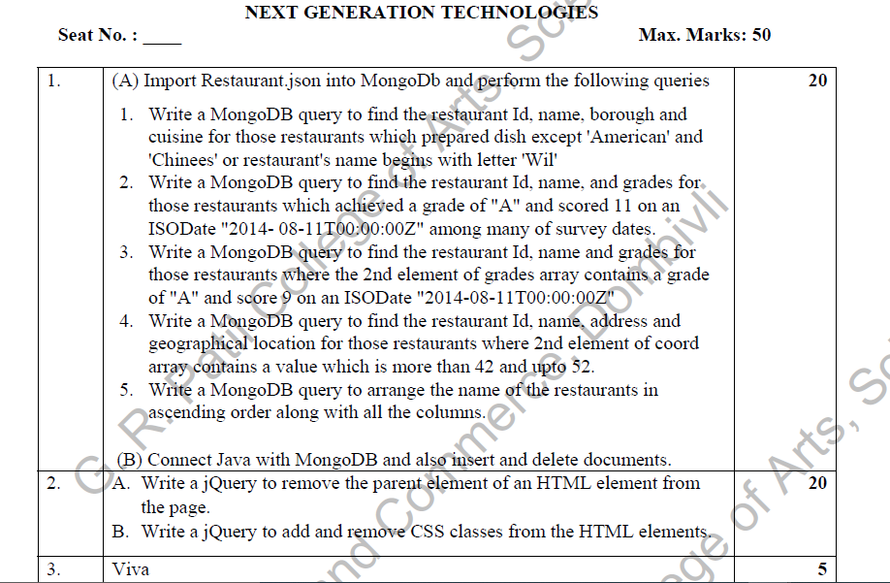

1A)

1,2,3,4,5

Sip no 11

1.B)

Slip no 2

2.A)

Code:

<!DOCTYPE html>

<html>

<head>

    <title></title>

    <script src="jquery-3.6.0.min.js"></script>

    <script>

        $(document).ready(

            function () {

                $("button").click(

                    function () {

                        $("p").unwrap();

                    }

                );

            }

        );

    </script>

    <style>

        div {

            background-color: yellow;

        }

        article {

            background-color: pink;

        }

    </style>

</head>

<body>

    <div>

        <p>This is a paragraph inside a div element.</p>

    </div>

    <article>

        <p>This is a paragraph inside an article element.</p>

    </article>

    <button>Remove the parent element of each p element</button>

</body>

</html>

Output:

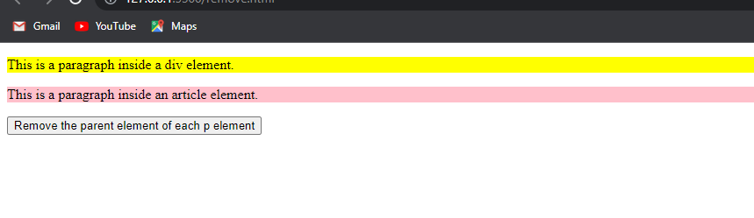

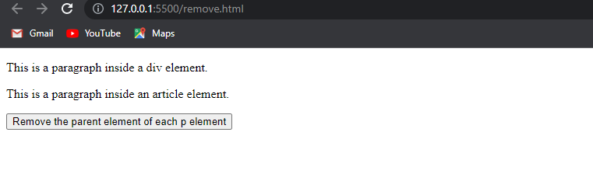

2.B)

Code:

Slip no 6

**Slip no 14:**



**1.**

**Code:**

Slip no 4

2.A)

Code:

<!DOCTYPE html>

<html>

<head>

    <title></title>

    <script src="jquery-3.6.0.min.js"></script>

    <script>

        $(document).ready(

            function () {

                $(".b1").click(

                    function () {

                        var str = $("p").html();

                        alert(str);

                    }

                );

                $(".b2").click(

                    function () {

                        $("body").html("<p>Hello World!</p>");

                    }

                );

            }

        );

    </script>

</head>

<body>

    <button class="b1">Get Paragraph's HTML Contents</button>

    <p>The quick <b>brown fox</b> jumps over the lazy dog.</p>

    <button class="b2">Write Message</button>

</body>

</html>

Output:

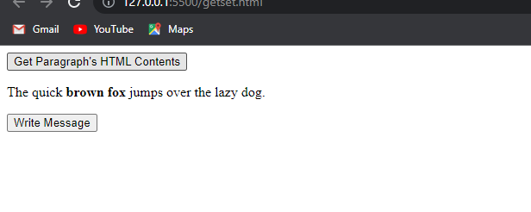

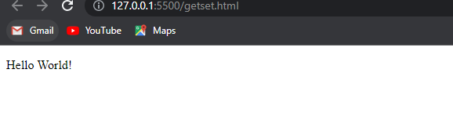

2.B)

Code:

Slip no 6

**Slip no 15**

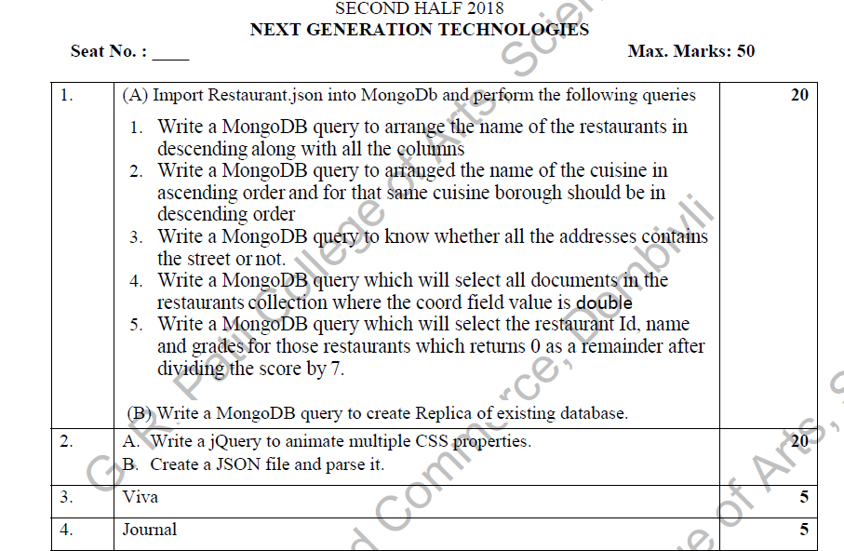

**1.A)**

**Code:**

db.rest.find().sort( {"name":-1} ).pretty()

Output:

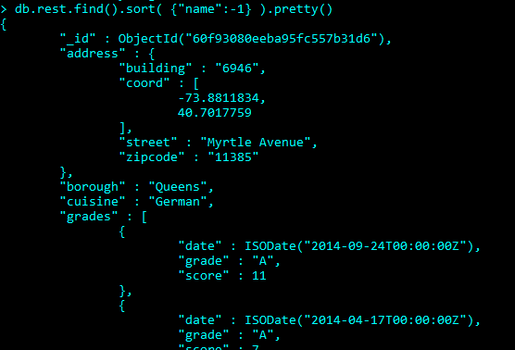

Code:

db.rest.find().sort( {"cuisine":1,"borough" : -1,} ).pretty()

Output:

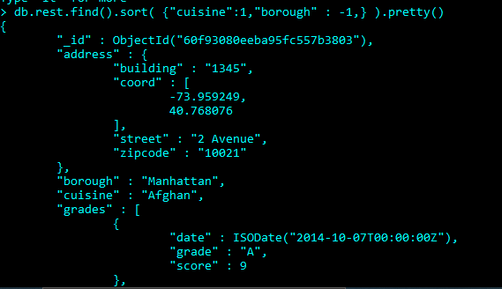

Code:

db.rest.find( {"address.street" : { $exists : true } } ).pretty()

Output:

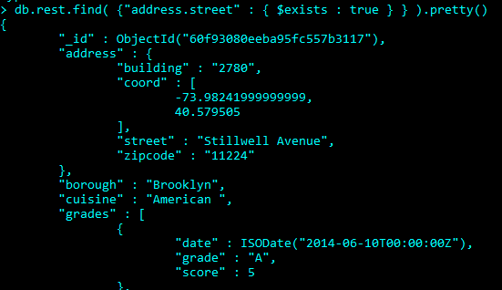

Code:

db.rest.find( {"address.coord" : {$type : 1} } ).pretty()

Output:

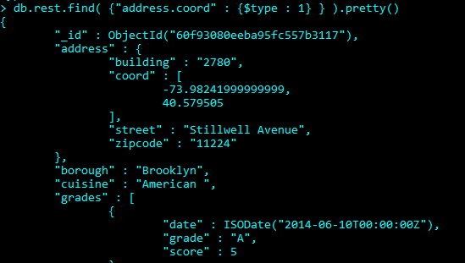

Code:

db.rest.find( {"grades.score" : {$mod : [7,0]}}, {"restaurant_id" : 1,"name":1,"grades":1} ).pretty()

Output:

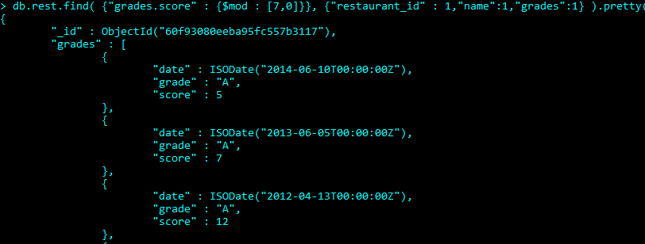

1.B)

Code:

Slip no 6

2.A)

Code:

Slip no 1

2.B)

Code:

Slip no 4

**Slip no 16**



1.

Code:

Slip no 2

2.A)

Code:

Slip no 14

2.B)

Code:

<!DOCTYPE html>

<html>

<head>

    <title></title>

    <script src="jquery-3.6.0.min.js"></script>

    <script>

        $(document).ready(

            function () {

                $(".b1").click(

                    function () {

                        $("p").prepend("<strong>Note:</strong> ");

                    }

                );

                $(".b2").click(

                    function () {

                        $("#container").append("This is demo text.");

                    }

                );

            }

        );

    </script>

</head>

<body>

    <button class="b1">Insert Text at Begin</button>

    <p>welcome in Jquery</p>

    <button class="b2">Insert Text at End</button>

    <div id="container">

        <p>Mulund College of Commerce</p>

    </div>

</body>

</html>

Output:

